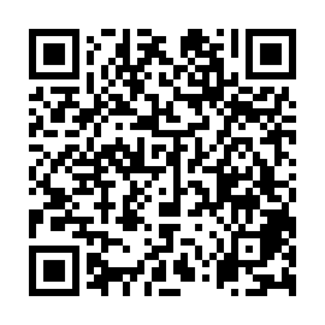
Prayer times for Barrow Island, Australia
Wed 1 May 2024 - Fri 31 May 2024
High Latitude Method: None
Prayer Calculation Method: Muslim World League
Asar Calculation Method: Shafi

Date | Day | Fajr | Sunrise | Dhuhr | Asr | Maghrib | Isha
1 | Wed | 5:20 | 6:35 | 12:15 | 3:31 | 5:55 | 7:06
2 | Thu | 5:20 | 6:36 | 12:15 | 3:30 | 5:55 | 7:06
3 | Fri | 5:21 | 6:36 | 12:15 | 3:30 | 5:54 | 7:05
4 | Sat | 5:21 | 6:37 | 12:15 | 3:29 | 5:54 | 7:05
5 | Sun | 5:21 | 6:37 | 12:15 | 3:29 | 5:53 | 7:04
6 | Mon | 5:21 | 6:37 | 12:15 | 3:29 | 5:53 | 7:04
7 | Tue | 5:22 | 6:38 | 12:15 | 3:28 | 5:52 | 7:04
8 | Wed | 5:22 | 6:38 | 12:15 | 3:28 | 5:52 | 7:03
9 | Thu | 5:22 | 6:38 | 12:15 | 3:28 | 5:51 | 7:03
10 | Fri | 5:23 | 6:39 | 12:15 | 3:27 | 5:51 | 7:02
11 | Sat | 5:23 | 6:39 | 12:15 | 3:27 | 5:50 | 7:02
12 | Sun | 5:23 | 6:40 | 12:15 | 3:27 | 5:50 | 7:02
13 | Mon | 5:23 | 6:40 | 12:15 | 3:26 | 5:49 | 7:01
14 | Tue | 5:24 | 6:40 | 12:15 | 3:26 | 5:49 | 7:01
15 | Wed | 5:24 | 6:41 | 12:15 | 3:26 | 5:48 | 7:01
16 | Thu | 5:24 | 6:41 | 12:15 | 3:25 | 5:48 | 7:01
17 | Fri | 5:25 | 6:42 | 12:15 | 3:25 | 5:48 | 7:00
18 | Sat | 5:25 | 6:42 | 12:15 | 3:25 | 5:47 | 7:00
19 | Sun | 5:25 | 6:43 | 12:15 | 3:25 | 5:47 | 7:00
20 | Mon | 5:26 | 6:43 | 12:15 | 3:25 | 5:47 | 7:00
21 | Tue | 5:26 | 6:43 | 12:15 | 3:24 | 5:47 | 7:00
22 | Wed | 5:26 | 6:44 | 12:15 | 3:24 | 5:46 | 6:59
23 | Thu | 5:27 | 6:44 | 12:15 | 3:24 | 5:46 | 6:59
24 | Fri | 5:27 | 6:45 | 12:15 | 3:24 | 5:46 | 6:59
25 | Sat | 5:27 | 6:45 | 12:15 | 3:24 | 5:46 | 6:59
26 | Sun | 5:28 | 6:45 | 12:15 | 3:24 | 5:45 | 6:59
27 | Mon | 5:28 | 6:46 | 12:16 | 3:24 | 5:45 | 6:59
28 | Tue | 5:28 | 6:46 | 12:16 | 3:23 | 5:45 | 6:59
29 | Wed | 5:28 | 6:47 | 12:16 | 3:23 | 5:45 | 6:59
30 | Thu | 5:29 | 6:47 | 12:16 | 3:23 | 5:45 | 6:59
31 | Fri | 5:29 | 6:47 | 12:16 | 3:23 | 5:45 | 6:59
Prayer times provided by https://www.salahtimes.com

