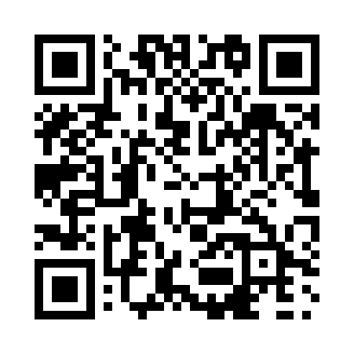
Prayer times for Upper Ferry, Newfoundland and Labrador, Canada
Mon 1 Apr 2024 - Tue 30 Apr 2024
High Latitude Method: Angle Based Rule
Prayer Calculation Method: Islamic Society of North America
Asar Calculation Method: Hanafi

Date | Day | Fajr | Sunrise | Dhuhr | Asr | Maghrib | Isha
1 | Mon | 5:36 | 7:04 | 1:31 | 5:59 | 7:58 | 9:26
2 | Tue | 5:34 | 7:02 | 1:30 | 6:00 | 7:59 | 9:28
3 | Wed | 5:32 | 7:00 | 1:30 | 6:01 | 8:01 | 9:30
4 | Thu | 5:29 | 6:58 | 1:30 | 6:02 | 8:02 | 9:32
5 | Fri | 5:27 | 6:56 | 1:30 | 6:03 | 8:04 | 9:33
6 | Sat | 5:25 | 6:54 | 1:29 | 6:04 | 8:05 | 9:35
7 | Sun | 5:22 | 6:52 | 1:29 | 6:05 | 8:06 | 9:37
8 | Mon | 5:20 | 6:50 | 1:29 | 6:06 | 8:08 | 9:39
9 | Tue | 5:17 | 6:48 | 1:28 | 6:07 | 8:09 | 9:40
10 | Wed | 5:15 | 6:46 | 1:28 | 6:08 | 8:11 | 9:42
11 | Thu | 5:13 | 6:45 | 1:28 | 6:09 | 8:12 | 9:44
12 | Fri | 5:10 | 6:43 | 1:28 | 6:10 | 8:14 | 9:46
13 | Sat | 5:08 | 6:41 | 1:27 | 6:11 | 8:15 | 9:48
14 | Sun | 5:06 | 6:39 | 1:27 | 6:12 | 8:16 | 9:50
15 | Mon | 5:03 | 6:37 | 1:27 | 6:13 | 8:18 | 9:52
16 | Tue | 5:01 | 6:35 | 1:27 | 6:14 | 8:19 | 9:53
17 | Wed | 4:59 | 6:33 | 1:26 | 6:15 | 8:21 | 9:55
18 | Thu | 4:56 | 6:31 | 1:26 | 6:16 | 8:22 | 9:57
19 | Fri | 4:54 | 6:29 | 1:26 | 6:17 | 8:24 | 9:59
20 | Sat | 4:52 | 6:27 | 1:26 | 6:18 | 8:25 | 10:01
21 | Sun | 4:49 | 6:26 | 1:26 | 6:19 | 8:26 | 10:03
22 | Mon | 4:47 | 6:24 | 1:25 | 6:20 | 8:28 | 10:05
23 | Tue | 4:45 | 6:22 | 1:25 | 6:20 | 8:29 | 10:07
24 | Wed | 4:42 | 6:20 | 1:25 | 6:21 | 8:31 | 10:09
25 | Thu | 4:40 | 6:18 | 1:25 | 6:22 | 8:32 | 10:11
26 | Fri | 4:37 | 6:17 | 1:25 | 6:23 | 8:33 | 10:13
27 | Sat | 4:35 | 6:15 | 1:25 | 6:24 | 8:35 | 10:15
28 | Sun | 4:33 | 6:13 | 1:24 | 6:25 | 8:36 | 10:17
29 | Mon | 4:31 | 6:12 | 1:24 | 6:26 | 8:38 | 10:19
30 | Tue | 4:28 | 6:10 | 1:24 | 6:27 | 8:39 | 10:21
Prayer times provided by https://www.salahtimes.com

