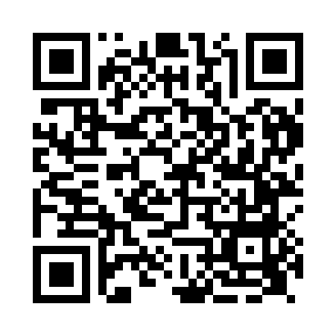

**Prayer times for Warcop, Cumbria, UK**

**Sun 1 Sep 2024 - Mon 30 Sep 2024**

**High Latitude Method: Angle Based Rule**

**Prayer Calculation Method: Islamic Society of North America**

**Asar Calculation Method: Hanafi**

|  |  |  |  |  |  |  |  |
| --- | --- | --- | --- | --- | --- | --- | --- |
| **Date** | **Day** | **Fajr** | **Sunrise** | **Dhuhr** | **Asr** | **Maghrib** | **Isha** |
| 1 | Sun | 4:27 | 6:18 | 1:09 | 5:49 | 8:00 | 9:50 |
| 2 | Mon | 4:30 | 6:19 | 1:09 | 5:47 | 7:58 | 9:47 |
| 3 | Tue | 4:32 | 6:21 | 1:09 | 5:45 | 7:55 | 9:44 |
| 4 | Wed | 4:35 | 6:23 | 1:08 | 5:43 | 7:53 | 9:40 |
| 5 | Thu | 4:37 | 6:25 | 1:08 | 5:41 | 7:50 | 9:37 |
| 6 | Fri | 4:40 | 6:27 | 1:08 | 5:39 | 7:48 | 9:34 |
| 7 | Sat | 4:42 | 6:28 | 1:07 | 5:37 | 7:45 | 9:31 |
| 8 | Sun | 4:44 | 6:30 | 1:07 | 5:35 | 7:43 | 9:28 |
| 9 | Mon | 4:47 | 6:32 | 1:07 | 5:33 | 7:40 | 9:25 |
| 10 | Tue | 4:49 | 6:34 | 1:06 | 5:31 | 7:38 | 9:22 |
| 11 | Wed | 4:51 | 6:36 | 1:06 | 5:29 | 7:35 | 9:19 |
| 12 | Thu | 4:54 | 6:38 | 1:06 | 5:27 | 7:33 | 9:16 |
| 13 | Fri | 4:56 | 6:39 | 1:05 | 5:25 | 7:30 | 9:13 |
| 14 | Sat | 4:58 | 6:41 | 1:05 | 5:23 | 7:28 | 9:10 |
| 15 | Sun | 5:00 | 6:43 | 1:05 | 5:21 | 7:25 | 9:07 |
| 16 | Mon | 5:03 | 6:45 | 1:04 | 5:19 | 7:22 | 9:04 |
| 17 | Tue | 5:05 | 6:47 | 1:04 | 5:16 | 7:20 | 9:02 |
| 18 | Wed | 5:07 | 6:49 | 1:03 | 5:14 | 7:17 | 8:59 |
| 19 | Thu | 5:09 | 6:50 | 1:03 | 5:12 | 7:15 | 8:56 |
| 20 | Fri | 5:11 | 6:52 | 1:03 | 5:10 | 7:12 | 8:53 |
| 21 | Sat | 5:13 | 6:54 | 1:02 | 5:08 | 7:10 | 8:50 |
| 22 | Sun | 5:15 | 6:56 | 1:02 | 5:06 | 7:07 | 8:47 |
| 23 | Mon | 5:18 | 6:58 | 1:02 | 5:04 | 7:05 | 8:45 |
| 24 | Tue | 5:20 | 6:59 | 1:01 | 5:01 | 7:02 | 8:42 |
| 25 | Wed | 5:22 | 7:01 | 1:01 | 4:59 | 7:00 | 8:39 |
| 26 | Thu | 5:24 | 7:03 | 1:01 | 4:57 | 6:57 | 8:36 |
| 27 | Fri | 5:26 | 7:05 | 1:00 | 4:55 | 6:55 | 8:34 |
| 28 | Sat | 5:28 | 7:07 | 1:00 | 4:53 | 6:52 | 8:31 |
| 29 | Sun | 5:30 | 7:09 | 1:00 | 4:51 | 6:50 | 8:28 |
| 30 | Mon | 5:32 | 7:11 | 12:59 | 4:48 | 6:47 | 8:26 |

**Prayer times provided by https://www.salahtimes.com**