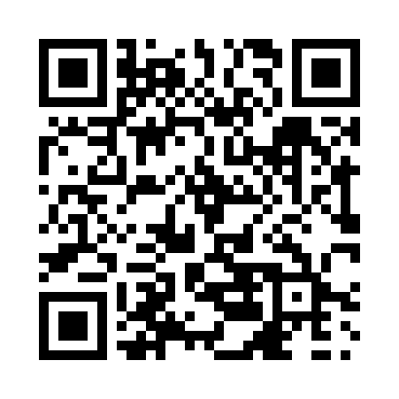

**Prayer times for Qikkigiaq, Quebec, Canada**

**Sun 1 Sep 2024 - Mon 30 Sep 2024**

**High Latitude Method: Angle Based Rule**

**Prayer Calculation Method: Islamic Society of North America**

**Asar Calculation Method: Hanafi**

|  |  |  |  |  |  |  |  |
| --- | --- | --- | --- | --- | --- | --- | --- |
| **Date** | **Day** | **Fajr** | **Sunrise** | **Dhuhr** | **Asr** | **Maghrib** | **Isha** |
| 1 | Sun | 3:27 | 5:53 | 1:02 | 5:40 | 8:10 | 10:36 |
| 2 | Mon | 3:28 | 5:55 | 1:02 | 5:38 | 8:07 | 10:34 |
| 3 | Tue | 3:29 | 5:58 | 1:01 | 5:35 | 8:03 | 10:32 |
| 4 | Wed | 3:32 | 6:00 | 1:01 | 5:33 | 8:00 | 10:27 |
| 5 | Thu | 3:37 | 6:03 | 1:01 | 5:30 | 7:57 | 10:22 |
| 6 | Fri | 3:41 | 6:06 | 1:00 | 5:28 | 7:53 | 10:17 |
| 7 | Sat | 3:45 | 6:08 | 1:00 | 5:25 | 7:50 | 10:12 |
| 8 | Sun | 3:49 | 6:11 | 1:00 | 5:23 | 7:47 | 10:08 |
| 9 | Mon | 3:53 | 6:14 | 12:59 | 5:20 | 7:44 | 10:03 |
| 10 | Tue | 3:57 | 6:16 | 12:59 | 5:18 | 7:40 | 9:58 |
| 11 | Wed | 4:01 | 6:19 | 12:59 | 5:15 | 7:37 | 9:54 |
| 12 | Thu | 4:05 | 6:21 | 12:58 | 5:12 | 7:34 | 9:49 |
| 13 | Fri | 4:09 | 6:24 | 12:58 | 5:10 | 7:30 | 9:45 |
| 14 | Sat | 4:12 | 6:27 | 12:58 | 5:07 | 7:27 | 9:41 |
| 15 | Sun | 4:16 | 6:29 | 12:57 | 5:04 | 7:24 | 9:37 |
| 16 | Mon | 4:19 | 6:32 | 12:57 | 5:02 | 7:20 | 9:32 |
| 17 | Tue | 4:23 | 6:34 | 12:56 | 4:59 | 7:17 | 9:28 |
| 18 | Wed | 4:26 | 6:37 | 12:56 | 4:56 | 7:14 | 9:24 |
| 19 | Thu | 4:30 | 6:40 | 12:56 | 4:53 | 7:10 | 9:20 |
| 20 | Fri | 4:33 | 6:42 | 12:55 | 4:51 | 7:07 | 9:16 |
| 21 | Sat | 4:36 | 6:45 | 12:55 | 4:48 | 7:04 | 9:12 |
| 22 | Sun | 4:39 | 6:47 | 12:55 | 4:45 | 7:00 | 9:08 |
| 23 | Mon | 4:43 | 6:50 | 12:54 | 4:42 | 6:57 | 9:04 |
| 24 | Tue | 4:46 | 6:53 | 12:54 | 4:40 | 6:54 | 9:00 |
| 25 | Wed | 4:49 | 6:55 | 12:54 | 4:37 | 6:51 | 8:57 |
| 26 | Thu | 4:52 | 6:58 | 12:53 | 4:34 | 6:47 | 8:53 |
| 27 | Fri | 4:55 | 7:00 | 12:53 | 4:31 | 6:44 | 8:49 |
| 28 | Sat | 4:58 | 7:03 | 12:53 | 4:28 | 6:41 | 8:46 |
| 29 | Sun | 5:01 | 7:06 | 12:52 | 4:26 | 6:37 | 8:42 |
| 30 | Mon | 5:04 | 7:08 | 12:52 | 4:23 | 6:34 | 8:38 |

**Prayer times provided by https://www.salahtimes.com**