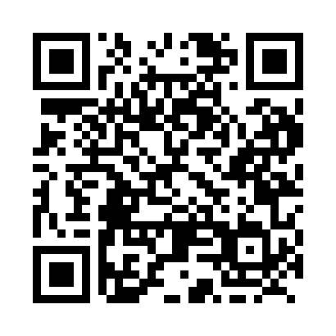
Prayer times for Quetico, Ontario, Canada
Mon 1 Jul 2024 - Wed 31 Jul 2024
High Latitude Method: Angle Based Rule
Prayer Calculation Method: Islamic Society of North America
Asar Calculation Method: Hanafi

Date | Day | Fajr | Sunrise | Dhuhr | Asr | Maghrib | Isha
1 | Mon | 4:06 | 6:05 | 2:08 | 7:37 | 10:10 | 12:09
2 | Tue | 4:07 | 6:06 | 2:08 | 7:37 | 10:10 | 12:09
3 | Wed | 4:07 | 6:07 | 2:08 | 7:37 | 10:09 | 12:09
4 | Thu | 4:08 | 6:07 | 2:08 | 7:37 | 10:09 | 12:08
5 | Fri | 4:08 | 6:08 | 2:08 | 7:37 | 10:08 | 12:08
6 | Sat | 4:09 | 6:09 | 2:09 | 7:37 | 10:08 | 12:08
7 | Sun | 4:09 | 6:10 | 2:09 | 7:37 | 10:07 | 12:08
8 | Mon | 4:10 | 6:11 | 2:09 | 7:36 | 10:07 | 12:08
9 | Tue | 4:10 | 6:12 | 2:09 | 7:36 | 10:06 | 12:07
10 | Wed | 4:11 | 6:13 | 2:09 | 7:36 | 10:05 | 12:07
11 | Thu | 4:11 | 6:13 | 2:09 | 7:36 | 10:05 | 12:07
12 | Fri | 4:12 | 6:14 | 2:09 | 7:35 | 10:04 | 12:07
13 | Sat | 4:12 | 6:15 | 2:10 | 7:35 | 10:03 | 12:06
14 | Sun | 4:13 | 6:16 | 2:10 | 7:34 | 10:02 | 12:06
15 | Mon | 4:14 | 6:18 | 2:10 | 7:34 | 10:01 | 12:05
16 | Tue | 4:14 | 6:19 | 2:10 | 7:33 | 10:00 | 12:05
17 | Wed | 4:15 | 6:20 | 2:10 | 7:33 | 10:00 | 12:05
18 | Thu | 4:15 | 6:21 | 2:10 | 7:32 | 9:59 | 12:04
19 | Fri | 4:17 | 6:22 | 2:10 | 7:32 | 9:57 | 12:02
20 | Sat | 4:19 | 6:23 | 2:10 | 7:31 | 9:56 | 12:00
21 | Sun | 4:21 | 6:24 | 2:10 | 7:31 | 9:55 | 11:58
22 | Mon | 4:24 | 6:26 | 2:10 | 7:30 | 9:54 | 11:56
23 | Tue | 4:26 | 6:27 | 2:10 | 7:29 | 9:53 | 11:53
24 | Wed | 4:28 | 6:28 | 2:10 | 7:29 | 9:52 | 11:51
25 | Thu | 4:30 | 6:29 | 2:10 | 7:28 | 9:51 | 11:49
26 | Fri | 4:32 | 6:31 | 2:10 | 7:27 | 9:49 | 11:47
27 | Sat | 4:34 | 6:32 | 2:10 | 7:26 | 9:48 | 11:45
28 | Sun | 4:37 | 6:33 | 2:10 | 7:26 | 9:47 | 11:42
29 | Mon | 4:39 | 6:34 | 2:10 | 7:25 | 9:45 | 11:40
30 | Tue | 4:41 | 6:36 | 2:10 | 7:24 | 9:44 | 11:38
31 | Wed | 4:43 | 6:37 | 2:10 | 7:23 | 9:42 | 11:36
Prayer times provided by https://www.salahtimes.com

