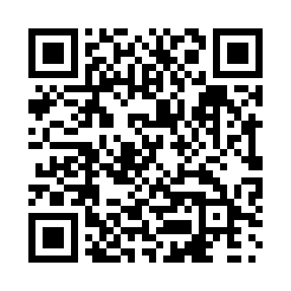
Prayer times for Aleza Lake, British Columbia, Canada
Mon 1 Apr 2024 - Tue 30 Apr 2024
High Latitude Method: Angle Based Rule
Prayer Calculation Method: Islamic Society of North America
Asar Calculation Method: Hanafi

Date | Day | Fajr | Sunrise | Dhuhr | Asr | Maghrib | Isha
1 | Mon | 4:55 | 6:39 | 1:12 | 5:38 | 7:46 | 9:30
2 | Tue | 4:52 | 6:37 | 1:11 | 5:40 | 7:47 | 9:32
3 | Wed | 4:49 | 6:34 | 1:11 | 5:41 | 7:49 | 9:34
4 | Thu | 4:46 | 6:32 | 1:11 | 5:42 | 7:51 | 9:37
5 | Fri | 4:43 | 6:29 | 1:11 | 5:44 | 7:53 | 9:39
6 | Sat | 4:40 | 6:27 | 1:10 | 5:45 | 7:55 | 9:42
7 | Sun | 4:37 | 6:24 | 1:10 | 5:46 | 7:57 | 9:44
8 | Mon | 4:34 | 6:22 | 1:10 | 5:48 | 7:59 | 9:47
9 | Tue | 4:31 | 6:19 | 1:09 | 5:49 | 8:01 | 9:49
10 | Wed | 4:28 | 6:17 | 1:09 | 5:50 | 8:02 | 9:52
11 | Thu | 4:25 | 6:15 | 1:09 | 5:52 | 8:04 | 9:54
12 | Fri | 4:22 | 6:12 | 1:09 | 5:53 | 8:06 | 9:57
13 | Sat | 4:19 | 6:10 | 1:08 | 5:54 | 8:08 | 10:00
14 | Sun | 4:16 | 6:08 | 1:08 | 5:55 | 8:10 | 10:03
15 | Mon | 4:12 | 6:05 | 1:08 | 5:57 | 8:12 | 10:05
16 | Tue | 4:09 | 6:03 | 1:08 | 5:58 | 8:14 | 10:08
17 | Wed | 4:06 | 6:01 | 1:08 | 5:59 | 8:16 | 10:11
18 | Thu | 4:03 | 5:58 | 1:07 | 6:00 | 8:17 | 10:14
19 | Fri | 3:59 | 5:56 | 1:07 | 6:02 | 8:19 | 10:17
20 | Sat | 3:56 | 5:54 | 1:07 | 6:03 | 8:21 | 10:19
21 | Sun | 3:53 | 5:51 | 1:07 | 6:04 | 8:23 | 10:22
22 | Mon | 3:49 | 5:49 | 1:06 | 6:05 | 8:25 | 10:25
23 | Tue | 3:46 | 5:47 | 1:06 | 6:07 | 8:27 | 10:28
24 | Wed | 3:43 | 5:45 | 1:06 | 6:08 | 8:29 | 10:31
25 | Thu | 3:39 | 5:42 | 1:06 | 6:09 | 8:31 | 10:35
26 | Fri | 3:36 | 5:40 | 1:06 | 6:10 | 8:32 | 10:38
27 | Sat | 3:32 | 5:38 | 1:06 | 6:11 | 8:34 | 10:41
28 | Sun | 3:29 | 5:36 | 1:06 | 6:12 | 8:36 | 10:44
29 | Mon | 3:25 | 5:34 | 1:05 | 6:14 | 8:38 | 10:47
30 | Tue | 3:22 | 5:32 | 1:05 | 6:15 | 8:40 | 10:51
Prayer times provided by https://www.salahtimes.com

