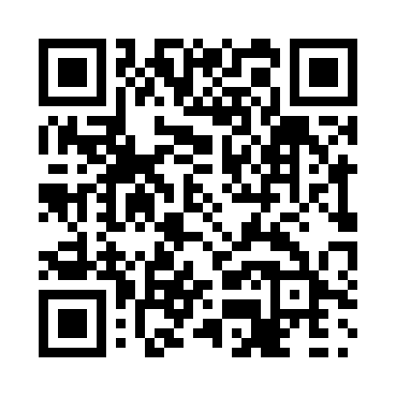
Prayer times for Heath Point, Quebec, Canada
Mon 1 Jul 2024 - Wed 31 Jul 2024
High Latitude Method: Angle Based Rule
Prayer Calculation Method: Islamic Society of North America
Asar Calculation Method: Hanafi

Date | Day | Fajr | Sunrise | Dhuhr | Asr | Maghrib | Isha
1 | Mon | 2:09 | 4:07 | 12:11 | 5:41 | 8:15 | 10:13
2 | Tue | 2:09 | 4:07 | 12:11 | 5:41 | 8:14 | 10:13
3 | Wed | 2:10 | 4:08 | 12:11 | 5:41 | 8:14 | 10:13
4 | Thu | 2:10 | 4:09 | 12:11 | 5:41 | 8:14 | 10:12
5 | Fri | 2:11 | 4:10 | 12:12 | 5:41 | 8:13 | 10:12
6 | Sat | 2:11 | 4:10 | 12:12 | 5:41 | 8:13 | 10:12
7 | Sun | 2:11 | 4:11 | 12:12 | 5:41 | 8:12 | 10:12
8 | Mon | 2:12 | 4:12 | 12:12 | 5:40 | 8:11 | 10:12
9 | Tue | 2:13 | 4:13 | 12:12 | 5:40 | 8:11 | 10:11
10 | Wed | 2:13 | 4:14 | 12:12 | 5:40 | 8:10 | 10:11
11 | Thu | 2:14 | 4:15 | 12:12 | 5:39 | 8:09 | 10:11
12 | Fri | 2:14 | 4:16 | 12:13 | 5:39 | 8:09 | 10:11
13 | Sat | 2:15 | 4:17 | 12:13 | 5:39 | 8:08 | 10:10
14 | Sun | 2:15 | 4:18 | 12:13 | 5:38 | 8:07 | 10:10
15 | Mon | 2:16 | 4:19 | 12:13 | 5:38 | 8:06 | 10:09
16 | Tue | 2:16 | 4:20 | 12:13 | 5:37 | 8:05 | 10:09
17 | Wed | 2:17 | 4:21 | 12:13 | 5:37 | 8:04 | 10:09
18 | Thu | 2:18 | 4:22 | 12:13 | 5:36 | 8:03 | 10:08
19 | Fri | 2:18 | 4:24 | 12:13 | 5:36 | 8:02 | 10:08
20 | Sat | 2:19 | 4:25 | 12:13 | 5:35 | 8:01 | 10:07
21 | Sun | 2:21 | 4:26 | 12:13 | 5:35 | 8:00 | 10:05
22 | Mon | 2:23 | 4:27 | 12:13 | 5:34 | 7:59 | 10:02
23 | Tue | 2:25 | 4:28 | 12:13 | 5:33 | 7:58 | 10:00
24 | Wed | 2:28 | 4:30 | 12:13 | 5:33 | 7:56 | 9:58
25 | Thu | 2:30 | 4:31 | 12:13 | 5:32 | 7:55 | 9:56
26 | Fri | 2:32 | 4:32 | 12:13 | 5:31 | 7:54 | 9:53
27 | Sat | 2:34 | 4:34 | 12:13 | 5:30 | 7:52 | 9:51
28 | Sun | 2:37 | 4:35 | 12:13 | 5:29 | 7:51 | 9:49
29 | Mon | 2:39 | 4:36 | 12:13 | 5:29 | 7:50 | 9:46
30 | Tue | 2:41 | 4:38 | 12:13 | 5:28 | 7:48 | 9:44
31 | Wed | 2:43 | 4:39 | 12:13 | 5:27 | 7:47 | 9:42
Prayer times provided by https://www.salahtimes.com

