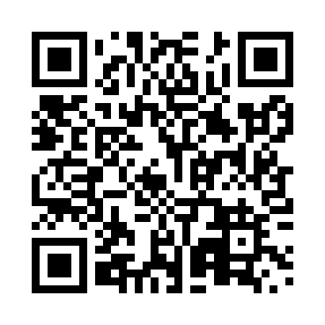
Prayer times for Baynes Lake, British Columbia, Canada
Mon 1 Apr 2024 - Tue 30 Apr 2024
High Latitude Method: Angle Based Rule
Prayer Calculation Method: Islamic Society of North America
Asar Calculation Method: Hanafi

Date | Day | Fajr | Sunrise | Dhuhr | Asr | Maghrib | Isha
1 | Mon | 5:46 | 7:17 | 1:44 | 6:13 | 8:13 | 9:45
2 | Tue | 5:43 | 7:15 | 1:44 | 6:14 | 8:15 | 9:46
3 | Wed | 5:41 | 7:13 | 1:44 | 6:15 | 8:16 | 9:48
4 | Thu | 5:38 | 7:10 | 1:44 | 6:16 | 8:18 | 9:50
5 | Fri | 5:36 | 7:08 | 1:43 | 6:17 | 8:19 | 9:52
6 | Sat | 5:33 | 7:06 | 1:43 | 6:18 | 8:21 | 9:54
7 | Sun | 5:31 | 7:04 | 1:43 | 6:19 | 8:22 | 9:56
8 | Mon | 5:28 | 7:02 | 1:43 | 6:20 | 8:24 | 9:58
9 | Tue | 5:26 | 7:00 | 1:42 | 6:22 | 8:25 | 10:00
10 | Wed | 5:23 | 6:58 | 1:42 | 6:23 | 8:27 | 10:02
11 | Thu | 5:21 | 6:56 | 1:42 | 6:24 | 8:28 | 10:04
12 | Fri | 5:18 | 6:54 | 1:41 | 6:25 | 8:30 | 10:06
13 | Sat | 5:16 | 6:52 | 1:41 | 6:26 | 8:31 | 10:08
14 | Sun | 5:13 | 6:50 | 1:41 | 6:27 | 8:33 | 10:10
15 | Mon | 5:11 | 6:48 | 1:41 | 6:28 | 8:34 | 10:12
16 | Tue | 5:08 | 6:46 | 1:40 | 6:29 | 8:36 | 10:14
17 | Wed | 5:06 | 6:44 | 1:40 | 6:30 | 8:37 | 10:16
18 | Thu | 5:03 | 6:42 | 1:40 | 6:31 | 8:39 | 10:18
19 | Fri | 5:01 | 6:40 | 1:40 | 6:32 | 8:40 | 10:20
20 | Sat | 4:58 | 6:38 | 1:40 | 6:33 | 8:42 | 10:22
21 | Sun | 4:56 | 6:36 | 1:39 | 6:34 | 8:43 | 10:24
22 | Mon | 4:53 | 6:34 | 1:39 | 6:35 | 8:45 | 10:26
23 | Tue | 4:51 | 6:32 | 1:39 | 6:36 | 8:46 | 10:29
24 | Wed | 4:48 | 6:31 | 1:39 | 6:36 | 8:48 | 10:31
25 | Thu | 4:46 | 6:29 | 1:39 | 6:37 | 8:49 | 10:33
26 | Fri | 4:43 | 6:27 | 1:39 | 6:38 | 8:51 | 10:35
27 | Sat | 4:41 | 6:25 | 1:38 | 6:39 | 8:52 | 10:37
28 | Sun | 4:38 | 6:23 | 1:38 | 6:40 | 8:54 | 10:40
29 | Mon | 4:36 | 6:22 | 1:38 | 6:41 | 8:55 | 10:42
30 | Tue | 4:33 | 6:20 | 1:38 | 6:42 | 8:57 | 10:44
Prayer times provided by https://www.salahtimes.com

