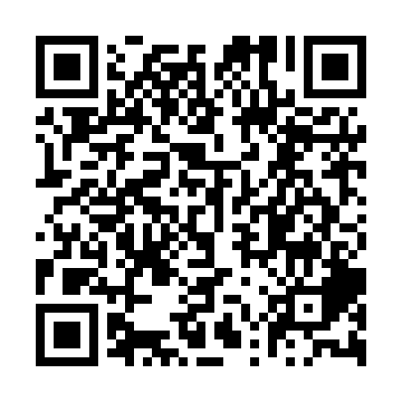
Prayer times for Paradise Island, Bahamas
Wed 1 May 2024 - Fri 31 May 2024
High Latitude Method: None
Prayer Calculation Method: Muslim World League
Asar Calculation Method: Shafi

Date | Day | Fajr | Sunrise | Dhuhr | Asr | Maghrib | Isha
1 | Wed | 5:11 | 6:33 | 1:06 | 4:35 | 7:40 | 8:57
2 | Thu | 5:10 | 6:32 | 1:06 | 4:34 | 7:40 | 8:58
3 | Fri | 5:09 | 6:32 | 1:06 | 4:34 | 7:41 | 8:58
4 | Sat | 5:08 | 6:31 | 1:06 | 4:34 | 7:41 | 8:59
5 | Sun | 5:08 | 6:30 | 1:06 | 4:34 | 7:42 | 9:00
6 | Mon | 5:07 | 6:30 | 1:06 | 4:33 | 7:42 | 9:00
7 | Tue | 5:06 | 6:29 | 1:06 | 4:33 | 7:43 | 9:01
8 | Wed | 5:05 | 6:28 | 1:06 | 4:33 | 7:43 | 9:02
9 | Thu | 5:04 | 6:28 | 1:06 | 4:33 | 7:44 | 9:03
10 | Fri | 5:03 | 6:27 | 1:06 | 4:33 | 7:44 | 9:03
11 | Sat | 5:03 | 6:27 | 1:06 | 4:32 | 7:45 | 9:04
12 | Sun | 5:02 | 6:26 | 1:06 | 4:32 | 7:45 | 9:05
13 | Mon | 5:01 | 6:26 | 1:06 | 4:32 | 7:46 | 9:05
14 | Tue | 5:00 | 6:25 | 1:06 | 4:32 | 7:47 | 9:06
15 | Wed | 5:00 | 6:25 | 1:06 | 4:32 | 7:47 | 9:07
16 | Thu | 4:59 | 6:24 | 1:06 | 4:32 | 7:48 | 9:08
17 | Fri | 4:58 | 6:24 | 1:06 | 4:32 | 7:48 | 9:08
18 | Sat | 4:58 | 6:23 | 1:06 | 4:31 | 7:49 | 9:09
19 | Sun | 4:57 | 6:23 | 1:06 | 4:31 | 7:49 | 9:10
20 | Mon | 4:56 | 6:22 | 1:06 | 4:31 | 7:50 | 9:10
21 | Tue | 4:56 | 6:22 | 1:06 | 4:31 | 7:50 | 9:11
22 | Wed | 4:55 | 6:22 | 1:06 | 4:31 | 7:51 | 9:12
23 | Thu | 4:55 | 6:21 | 1:06 | 4:31 | 7:51 | 9:12
24 | Fri | 4:54 | 6:21 | 1:06 | 4:31 | 7:52 | 9:13
25 | Sat | 4:54 | 6:21 | 1:06 | 4:31 | 7:52 | 9:14
26 | Sun | 4:53 | 6:20 | 1:06 | 4:31 | 7:53 | 9:14
27 | Mon | 4:53 | 6:20 | 1:07 | 4:31 | 7:53 | 9:15
28 | Tue | 4:53 | 6:20 | 1:07 | 4:31 | 7:54 | 9:16
29 | Wed | 4:52 | 6:20 | 1:07 | 4:31 | 7:54 | 9:16
30 | Thu | 4:52 | 6:20 | 1:07 | 4:31 | 7:55 | 9:17
31 | Fri | 4:52 | 6:19 | 1:07 | 4:31 | 7:55 | 9:17
Prayer times provided by https://www.salahtimes.com

