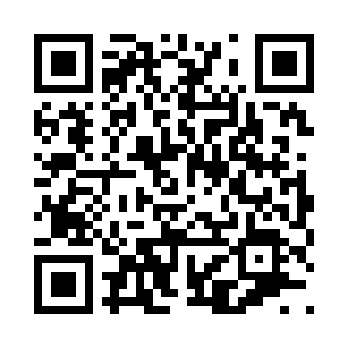
Prayer times for Corsica, Pennsylvania, USA
Wed 1 May 2024 - Fri 31 May 2024
High Latitude Method: Angle Based Rule
Prayer Calculation Method: Islamic Society of North America
Asar Calculation Method: Shafi

Date | Day | Fajr | Sunrise | Dhuhr | Asr | Maghrib | Isha
1 | Wed | 4:48 | 6:14 | 1:14 | 5:06 | 8:15 | 9:41
2 | Thu | 4:46 | 6:12 | 1:14 | 5:06 | 8:16 | 9:42
3 | Fri | 4:44 | 6:11 | 1:14 | 5:07 | 8:17 | 9:44
4 | Sat | 4:43 | 6:10 | 1:14 | 5:07 | 8:18 | 9:45
5 | Sun | 4:41 | 6:09 | 1:13 | 5:07 | 8:19 | 9:47
6 | Mon | 4:40 | 6:08 | 1:13 | 5:07 | 8:20 | 9:48
7 | Tue | 4:38 | 6:06 | 1:13 | 5:08 | 8:21 | 9:50
8 | Wed | 4:36 | 6:05 | 1:13 | 5:08 | 8:22 | 9:51
9 | Thu | 4:35 | 6:04 | 1:13 | 5:08 | 8:23 | 9:52
10 | Fri | 4:33 | 6:03 | 1:13 | 5:09 | 8:24 | 9:54
11 | Sat | 4:32 | 6:02 | 1:13 | 5:09 | 8:25 | 9:55
12 | Sun | 4:30 | 6:01 | 1:13 | 5:09 | 8:26 | 9:57
13 | Mon | 4:29 | 6:00 | 1:13 | 5:09 | 8:27 | 9:58
14 | Tue | 4:28 | 5:59 | 1:13 | 5:10 | 8:28 | 9:59
15 | Wed | 4:26 | 5:58 | 1:13 | 5:10 | 8:29 | 10:01
16 | Thu | 4:25 | 5:57 | 1:13 | 5:10 | 8:30 | 10:02
17 | Fri | 4:24 | 5:56 | 1:13 | 5:11 | 8:31 | 10:04
18 | Sat | 4:22 | 5:55 | 1:13 | 5:11 | 8:32 | 10:05
19 | Sun | 4:21 | 5:54 | 1:13 | 5:11 | 8:33 | 10:06
20 | Mon | 4:20 | 5:54 | 1:13 | 5:11 | 8:34 | 10:08
21 | Tue | 4:19 | 5:53 | 1:13 | 5:12 | 8:35 | 10:09
22 | Wed | 4:18 | 5:52 | 1:14 | 5:12 | 8:36 | 10:10
23 | Thu | 4:16 | 5:51 | 1:14 | 5:12 | 8:36 | 10:12
24 | Fri | 4:15 | 5:51 | 1:14 | 5:13 | 8:37 | 10:13
25 | Sat | 4:14 | 5:50 | 1:14 | 5:13 | 8:38 | 10:14
26 | Sun | 4:13 | 5:49 | 1:14 | 5:13 | 8:39 | 10:15
27 | Mon | 4:12 | 5:49 | 1:14 | 5:13 | 8:40 | 10:16
28 | Tue | 4:11 | 5:48 | 1:14 | 5:14 | 8:41 | 10:18
29 | Wed | 4:10 | 5:48 | 1:14 | 5:14 | 8:41 | 10:19
30 | Thu | 4:10 | 5:47 | 1:14 | 5:14 | 8:42 | 10:20
31 | Fri | 4:09 | 5:47 | 1:15 | 5:15 | 8:43 | 10:21
Prayer times provided by https://www.salahtimes.com

