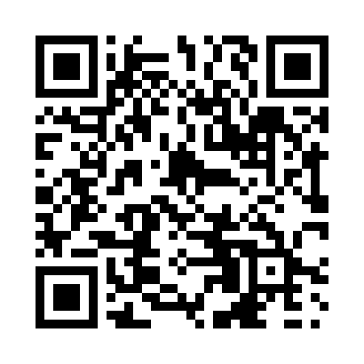

**Prayer times for Rang-Sept, New Brunswick, Canada**

**Wed 1 Jan 2025 - Fri 31 Jan 2025**

**High Latitude Method: Angle Based Rule**

**Prayer Calculation Method: Islamic Society of North America**

**Asar Calculation Method: Hanafi**

|  |  |  |  |  |  |  |  |
| --- | --- | --- | --- | --- | --- | --- | --- |
| **Date** | **Day** | **Fajr** | **Sunrise** | **Dhuhr** | **Asr** | **Maghrib** | **Isha** |
| 1 | Wed | 6:44 | 8:18 | 12:33 | 3:04 | 4:49 | 6:23 |
| 2 | Thu | 6:44 | 8:18 | 12:34 | 3:05 | 4:50 | 6:23 |
| 3 | Fri | 6:44 | 8:18 | 12:34 | 3:06 | 4:51 | 6:24 |
| 4 | Sat | 6:44 | 8:18 | 12:35 | 3:07 | 4:52 | 6:25 |
| 5 | Sun | 6:44 | 8:17 | 12:35 | 3:08 | 4:53 | 6:26 |
| 6 | Mon | 6:44 | 8:17 | 12:35 | 3:09 | 4:54 | 6:27 |
| 7 | Tue | 6:44 | 8:17 | 12:36 | 3:10 | 4:55 | 6:28 |
| 8 | Wed | 6:44 | 8:17 | 12:36 | 3:12 | 4:56 | 6:29 |
| 9 | Thu | 6:43 | 8:16 | 12:37 | 3:13 | 4:58 | 6:30 |
| 10 | Fri | 6:43 | 8:16 | 12:37 | 3:14 | 4:59 | 6:31 |
| 11 | Sat | 6:43 | 8:15 | 12:37 | 3:15 | 5:00 | 6:32 |
| 12 | Sun | 6:42 | 8:15 | 12:38 | 3:17 | 5:01 | 6:34 |
| 13 | Mon | 6:42 | 8:14 | 12:38 | 3:18 | 5:03 | 6:35 |
| 14 | Tue | 6:42 | 8:14 | 12:39 | 3:19 | 5:04 | 6:36 |
| 15 | Wed | 6:41 | 8:13 | 12:39 | 3:20 | 5:05 | 6:37 |
| 16 | Thu | 6:41 | 8:12 | 12:39 | 3:22 | 5:07 | 6:38 |
| 17 | Fri | 6:40 | 8:11 | 12:40 | 3:23 | 5:08 | 6:39 |
| 18 | Sat | 6:40 | 8:11 | 12:40 | 3:25 | 5:10 | 6:41 |
| 19 | Sun | 6:39 | 8:10 | 12:40 | 3:26 | 5:11 | 6:42 |
| 20 | Mon | 6:38 | 8:09 | 12:41 | 3:27 | 5:13 | 6:43 |
| 21 | Tue | 6:38 | 8:08 | 12:41 | 3:29 | 5:14 | 6:44 |
| 22 | Wed | 6:37 | 8:07 | 12:41 | 3:30 | 5:16 | 6:46 |
| 23 | Thu | 6:36 | 8:06 | 12:41 | 3:32 | 5:17 | 6:47 |
| 24 | Fri | 6:35 | 8:05 | 12:42 | 3:33 | 5:19 | 6:48 |
| 25 | Sat | 6:35 | 8:04 | 12:42 | 3:35 | 5:20 | 6:50 |
| 26 | Sun | 6:34 | 8:03 | 12:42 | 3:36 | 5:22 | 6:51 |
| 27 | Mon | 6:33 | 8:02 | 12:42 | 3:38 | 5:23 | 6:52 |
| 28 | Tue | 6:32 | 8:01 | 12:42 | 3:39 | 5:25 | 6:54 |
| 29 | Wed | 6:31 | 8:00 | 12:43 | 3:41 | 5:26 | 6:55 |
| 30 | Thu | 6:30 | 7:58 | 12:43 | 3:42 | 5:28 | 6:56 |
| 31 | Fri | 6:29 | 7:57 | 12:43 | 3:44 | 5:29 | 6:58 |

**Prayer times provided by https://www.salahtimes.com**