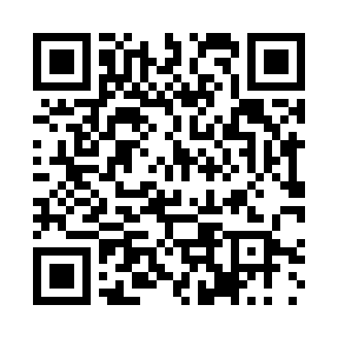
Prayer times for Ilevtsi, Bulgaria
Wed 1 May 2024 - Fri 31 May 2024
High Latitude Method: Angle Based Rule
Prayer Calculation Method: Muslim World League
Asar Calculation Method: Hanafi

Date | Day | Fajr | Sunrise | Dhuhr | Asr | Maghrib | Isha
1 | Wed | 4:22 | 6:12 | 1:16 | 6:14 | 8:20 | 10:03
2 | Thu | 4:20 | 6:11 | 1:16 | 6:14 | 8:21 | 10:05
3 | Fri | 4:18 | 6:10 | 1:16 | 6:15 | 8:22 | 10:07
4 | Sat | 4:16 | 6:08 | 1:15 | 6:16 | 8:23 | 10:08
5 | Sun | 4:14 | 6:07 | 1:15 | 6:16 | 8:24 | 10:10
6 | Mon | 4:12 | 6:06 | 1:15 | 6:17 | 8:25 | 10:12
7 | Tue | 4:10 | 6:05 | 1:15 | 6:18 | 8:26 | 10:14
8 | Wed | 4:08 | 6:03 | 1:15 | 6:18 | 8:27 | 10:15
9 | Thu | 4:06 | 6:02 | 1:15 | 6:19 | 8:29 | 10:17
10 | Fri | 4:05 | 6:01 | 1:15 | 6:19 | 8:30 | 10:19
11 | Sat | 4:03 | 6:00 | 1:15 | 6:20 | 8:31 | 10:20
12 | Sun | 4:01 | 5:59 | 1:15 | 6:21 | 8:32 | 10:22
13 | Mon | 3:59 | 5:58 | 1:15 | 6:21 | 8:33 | 10:24
14 | Tue | 3:57 | 5:57 | 1:15 | 6:22 | 8:34 | 10:25
15 | Wed | 3:56 | 5:56 | 1:15 | 6:23 | 8:35 | 10:27
16 | Thu | 3:54 | 5:55 | 1:15 | 6:23 | 8:36 | 10:29
17 | Fri | 3:52 | 5:54 | 1:15 | 6:24 | 8:37 | 10:30
18 | Sat | 3:51 | 5:53 | 1:15 | 6:24 | 8:38 | 10:32
19 | Sun | 3:49 | 5:52 | 1:15 | 6:25 | 8:39 | 10:33
20 | Mon | 3:48 | 5:51 | 1:15 | 6:26 | 8:40 | 10:35
21 | Tue | 3:46 | 5:50 | 1:15 | 6:26 | 8:41 | 10:37
22 | Wed | 3:44 | 5:49 | 1:15 | 6:27 | 8:42 | 10:38
23 | Thu | 3:43 | 5:48 | 1:15 | 6:27 | 8:43 | 10:40
24 | Fri | 3:42 | 5:48 | 1:16 | 6:28 | 8:44 | 10:41
25 | Sat | 3:40 | 5:47 | 1:16 | 6:28 | 8:45 | 10:43
26 | Sun | 3:39 | 5:46 | 1:16 | 6:29 | 8:46 | 10:44
27 | Mon | 3:37 | 5:46 | 1:16 | 6:29 | 8:47 | 10:46
28 | Tue | 3:36 | 5:45 | 1:16 | 6:30 | 8:48 | 10:47
29 | Wed | 3:35 | 5:44 | 1:16 | 6:30 | 8:48 | 10:48
30 | Thu | 3:34 | 5:44 | 1:16 | 6:31 | 8:49 | 10:50
31 | Fri | 3:33 | 5:43 | 1:16 | 6:32 | 8:50 | 10:51
Prayer times provided by https://www.salahtimes.com

