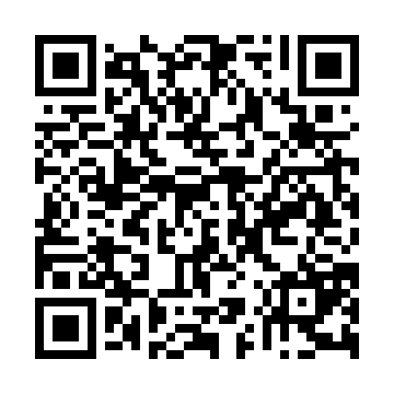
Prayer times for Barquisimeto, Venezuela
Wed 1 May 2024 - Fri 31 May 2024
High Latitude Method: None
Prayer Calculation Method: Muslim World League
Asar Calculation Method: Shafi

Date | Day | Fajr | Sunrise | Dhuhr | Asr | Maghrib | Isha
1 | Wed | 5:07 | 6:20 | 12:34 | 3:49 | 6:49 | 7:58
2 | Thu | 5:06 | 6:19 | 12:34 | 3:49 | 6:49 | 7:58
3 | Fri | 5:06 | 6:19 | 12:34 | 3:49 | 6:49 | 7:59
4 | Sat | 5:05 | 6:19 | 12:34 | 3:50 | 6:49 | 7:59
5 | Sun | 5:05 | 6:18 | 12:34 | 3:50 | 6:50 | 7:59
6 | Mon | 5:04 | 6:18 | 12:34 | 3:51 | 6:50 | 7:59
7 | Tue | 5:04 | 6:18 | 12:34 | 3:51 | 6:50 | 8:00
8 | Wed | 5:04 | 6:18 | 12:34 | 3:52 | 6:50 | 8:00
9 | Thu | 5:03 | 6:17 | 12:34 | 3:52 | 6:50 | 8:00
10 | Fri | 5:03 | 6:17 | 12:34 | 3:52 | 6:50 | 8:00
11 | Sat | 5:02 | 6:17 | 12:34 | 3:53 | 6:51 | 8:01
12 | Sun | 5:02 | 6:17 | 12:34 | 3:53 | 6:51 | 8:01
13 | Mon | 5:02 | 6:16 | 12:34 | 3:54 | 6:51 | 8:01
14 | Tue | 5:01 | 6:16 | 12:34 | 3:54 | 6:51 | 8:02
15 | Wed | 5:01 | 6:16 | 12:34 | 3:54 | 6:51 | 8:02
16 | Thu | 5:01 | 6:16 | 12:34 | 3:55 | 6:52 | 8:02
17 | Fri | 5:01 | 6:16 | 12:34 | 3:55 | 6:52 | 8:03
18 | Sat | 5:00 | 6:16 | 12:34 | 3:56 | 6:52 | 8:03
19 | Sun | 5:00 | 6:16 | 12:34 | 3:56 | 6:52 | 8:03
20 | Mon | 5:00 | 6:15 | 12:34 | 3:56 | 6:53 | 8:04
21 | Tue | 5:00 | 6:15 | 12:34 | 3:57 | 6:53 | 8:04
22 | Wed | 4:59 | 6:15 | 12:34 | 3:57 | 6:53 | 8:04
23 | Thu | 4:59 | 6:15 | 12:34 | 3:57 | 6:53 | 8:05
24 | Fri | 4:59 | 6:15 | 12:34 | 3:58 | 6:54 | 8:05
25 | Sat | 4:59 | 6:15 | 12:34 | 3:58 | 6:54 | 8:05
26 | Sun | 4:59 | 6:15 | 12:34 | 3:59 | 6:54 | 8:06
27 | Mon | 4:59 | 6:15 | 12:35 | 3:59 | 6:54 | 8:06
28 | Tue | 4:58 | 6:15 | 12:35 | 3:59 | 6:55 | 8:07
29 | Wed | 4:58 | 6:15 | 12:35 | 4:00 | 6:55 | 8:07
30 | Thu | 4:58 | 6:15 | 12:35 | 4:00 | 6:55 | 8:07
31 | Fri | 4:58 | 6:15 | 12:35 | 4:00 | 6:55 | 8:08
Prayer times provided by https://www.salahtimes.com

