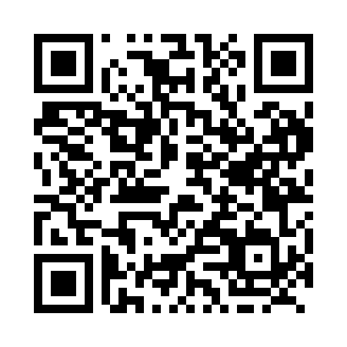

**Prayer times for Kinoosao, Saskatchewan, Canada**

**Sun 1 Sep 2024 - Mon 30 Sep 2024**

**High Latitude Method: Angle Based Rule**

**Prayer Calculation Method: Islamic Society of North America**

**Asar Calculation Method: Hanafi**

|  |  |  |  |  |  |  |  |
| --- | --- | --- | --- | --- | --- | --- | --- |
| **Date** | **Day** | **Fajr** | **Sunrise** | **Dhuhr** | **Asr** | **Maghrib** | **Isha** |
| 1 | Sun | 3:51 | 5:52 | 12:48 | 5:27 | 7:43 | 9:43 |
| 2 | Mon | 3:54 | 5:54 | 12:47 | 5:25 | 7:40 | 9:39 |
| 3 | Tue | 3:57 | 5:56 | 12:47 | 5:22 | 7:38 | 9:36 |
| 4 | Wed | 4:00 | 5:58 | 12:47 | 5:20 | 7:35 | 9:32 |
| 5 | Thu | 4:03 | 6:00 | 12:46 | 5:18 | 7:32 | 9:29 |
| 6 | Fri | 4:05 | 6:02 | 12:46 | 5:16 | 7:29 | 9:25 |
| 7 | Sat | 4:08 | 6:04 | 12:46 | 5:14 | 7:27 | 9:22 |
| 8 | Sun | 4:11 | 6:06 | 12:45 | 5:12 | 7:24 | 9:18 |
| 9 | Mon | 4:14 | 6:08 | 12:45 | 5:10 | 7:21 | 9:15 |
| 10 | Tue | 4:16 | 6:10 | 12:45 | 5:07 | 7:18 | 9:11 |
| 11 | Wed | 4:19 | 6:12 | 12:44 | 5:05 | 7:16 | 9:08 |
| 12 | Thu | 4:22 | 6:14 | 12:44 | 5:03 | 7:13 | 9:05 |
| 13 | Fri | 4:24 | 6:16 | 12:44 | 5:01 | 7:10 | 9:01 |
| 14 | Sat | 4:27 | 6:18 | 12:43 | 4:58 | 7:07 | 8:58 |
| 15 | Sun | 4:30 | 6:20 | 12:43 | 4:56 | 7:05 | 8:55 |
| 16 | Mon | 4:32 | 6:22 | 12:43 | 4:54 | 7:02 | 8:52 |
| 17 | Tue | 4:35 | 6:24 | 12:42 | 4:52 | 6:59 | 8:48 |
| 18 | Wed | 4:37 | 6:26 | 12:42 | 4:49 | 6:56 | 8:45 |
| 19 | Thu | 4:39 | 6:28 | 12:42 | 4:47 | 6:54 | 8:42 |
| 20 | Fri | 4:42 | 6:30 | 12:41 | 4:45 | 6:51 | 8:39 |
| 21 | Sat | 4:44 | 6:32 | 12:41 | 4:42 | 6:48 | 8:36 |
| 22 | Sun | 4:47 | 6:34 | 12:41 | 4:40 | 6:45 | 8:33 |
| 23 | Mon | 4:49 | 6:37 | 12:40 | 4:38 | 6:43 | 8:30 |
| 24 | Tue | 4:51 | 6:39 | 12:40 | 4:35 | 6:40 | 8:27 |
| 25 | Wed | 4:54 | 6:41 | 12:39 | 4:33 | 6:37 | 8:24 |
| 26 | Thu | 4:56 | 6:43 | 12:39 | 4:31 | 6:34 | 8:21 |
| 27 | Fri | 4:58 | 6:45 | 12:39 | 4:28 | 6:32 | 8:18 |
| 28 | Sat | 5:01 | 6:47 | 12:38 | 4:26 | 6:29 | 8:15 |
| 29 | Sun | 5:03 | 6:49 | 12:38 | 4:24 | 6:26 | 8:12 |
| 30 | Mon | 5:05 | 6:51 | 12:38 | 4:21 | 6:23 | 8:09 |

**Prayer times provided by https://www.salahtimes.com**