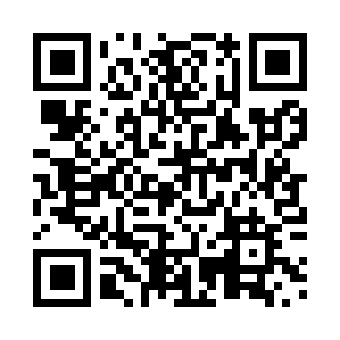
Prayer times for Reeds Point, New Brunswick, Canada
Mon 1 Jul 2024 - Wed 31 Jul 2024
High Latitude Method: Angle Based Rule
Prayer Calculation Method: Islamic Society of North America
Asar Calculation Method: Hanafi

Date | Day | Fajr | Sunrise | Dhuhr | Asr | Maghrib | Isha
1 | Mon | 3:42 | 5:40 | 1:28 | 6:51 | 9:16 | 11:13
2 | Tue | 3:43 | 5:40 | 1:28 | 6:51 | 9:16 | 11:13
3 | Wed | 3:44 | 5:41 | 1:28 | 6:51 | 9:16 | 11:12
4 | Thu | 3:45 | 5:42 | 1:29 | 6:51 | 9:15 | 11:12
5 | Fri | 3:46 | 5:42 | 1:29 | 6:51 | 9:15 | 11:11
6 | Sat | 3:47 | 5:43 | 1:29 | 6:50 | 9:14 | 11:10
7 | Sun | 3:48 | 5:44 | 1:29 | 6:50 | 9:14 | 11:09
8 | Mon | 3:50 | 5:44 | 1:29 | 6:50 | 9:14 | 11:08
9 | Tue | 3:51 | 5:45 | 1:29 | 6:50 | 9:13 | 11:07
10 | Wed | 3:52 | 5:46 | 1:29 | 6:50 | 9:12 | 11:06
11 | Thu | 3:54 | 5:47 | 1:30 | 6:49 | 9:12 | 11:05
12 | Fri | 3:55 | 5:48 | 1:30 | 6:49 | 9:11 | 11:04
13 | Sat | 3:56 | 5:49 | 1:30 | 6:49 | 9:11 | 11:02
14 | Sun | 3:58 | 5:50 | 1:30 | 6:49 | 9:10 | 11:01
15 | Mon | 3:59 | 5:51 | 1:30 | 6:48 | 9:09 | 11:00
16 | Tue | 4:01 | 5:51 | 1:30 | 6:48 | 9:08 | 10:58
17 | Wed | 4:03 | 5:52 | 1:30 | 6:47 | 9:07 | 10:57
18 | Thu | 4:04 | 5:53 | 1:30 | 6:47 | 9:07 | 10:56
19 | Fri | 4:06 | 5:54 | 1:30 | 6:46 | 9:06 | 10:54
20 | Sat | 4:07 | 5:55 | 1:30 | 6:46 | 9:05 | 10:53
21 | Sun | 4:09 | 5:56 | 1:30 | 6:45 | 9:04 | 10:51
22 | Mon | 4:11 | 5:58 | 1:30 | 6:45 | 9:03 | 10:49
23 | Tue | 4:12 | 5:59 | 1:30 | 6:44 | 9:02 | 10:48
24 | Wed | 4:14 | 6:00 | 1:30 | 6:44 | 9:01 | 10:46
25 | Thu | 4:16 | 6:01 | 1:30 | 6:43 | 9:00 | 10:44
26 | Fri | 4:17 | 6:02 | 1:30 | 6:42 | 8:59 | 10:43
27 | Sat | 4:19 | 6:03 | 1:30 | 6:42 | 8:57 | 10:41
28 | Sun | 4:21 | 6:04 | 1:30 | 6:41 | 8:56 | 10:39
29 | Mon | 4:23 | 6:05 | 1:30 | 6:40 | 8:55 | 10:37
30 | Tue | 4:24 | 6:06 | 1:30 | 6:40 | 8:54 | 10:35
31 | Wed | 4:26 | 6:08 | 1:30 | 6:39 | 8:53 | 10:34
Prayer times provided by https://www.salahtimes.com

