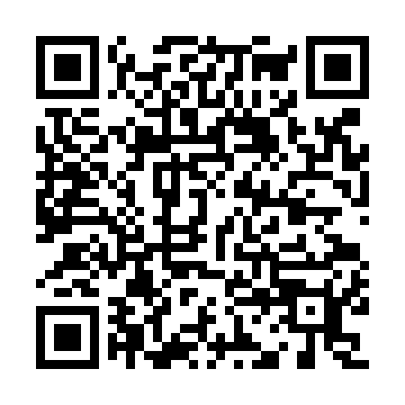
Prayer times for Misima Island, Papua New Guinea
Wed 1 May 2024 - Fri 31 May 2024
High Latitude Method: None
Prayer Calculation Method: Muslim World League
Asar Calculation Method: Shafi

Date | Day | Fajr | Sunrise | Dhuhr | Asr | Maghrib | Isha
1 | Wed | 4:42 | 5:54 | 11:46 | 3:07 | 5:38 | 6:46
2 | Thu | 4:42 | 5:55 | 11:46 | 3:07 | 5:38 | 6:46
3 | Fri | 4:43 | 5:55 | 11:46 | 3:07 | 5:37 | 6:45
4 | Sat | 4:43 | 5:55 | 11:46 | 3:07 | 5:37 | 6:45
5 | Sun | 4:43 | 5:55 | 11:46 | 3:06 | 5:37 | 6:45
6 | Mon | 4:43 | 5:55 | 11:46 | 3:06 | 5:36 | 6:45
7 | Tue | 4:43 | 5:55 | 11:46 | 3:06 | 5:36 | 6:44
8 | Wed | 4:43 | 5:55 | 11:46 | 3:06 | 5:36 | 6:44
9 | Thu | 4:43 | 5:56 | 11:46 | 3:06 | 5:36 | 6:44
10 | Fri | 4:43 | 5:56 | 11:46 | 3:06 | 5:35 | 6:44
11 | Sat | 4:43 | 5:56 | 11:46 | 3:06 | 5:35 | 6:44
12 | Sun | 4:43 | 5:56 | 11:46 | 3:06 | 5:35 | 6:44
13 | Mon | 4:43 | 5:56 | 11:45 | 3:06 | 5:35 | 6:44
14 | Tue | 4:43 | 5:56 | 11:45 | 3:05 | 5:34 | 6:43
15 | Wed | 4:43 | 5:57 | 11:46 | 3:05 | 5:34 | 6:43
16 | Thu | 4:43 | 5:57 | 11:46 | 3:05 | 5:34 | 6:43
17 | Fri | 4:44 | 5:57 | 11:46 | 3:05 | 5:34 | 6:43
18 | Sat | 4:44 | 5:57 | 11:46 | 3:05 | 5:34 | 6:43
19 | Sun | 4:44 | 5:58 | 11:46 | 3:05 | 5:34 | 6:43
20 | Mon | 4:44 | 5:58 | 11:46 | 3:05 | 5:34 | 6:43
21 | Tue | 4:44 | 5:58 | 11:46 | 3:05 | 5:33 | 6:43
22 | Wed | 4:44 | 5:58 | 11:46 | 3:05 | 5:33 | 6:43
23 | Thu | 4:44 | 5:58 | 11:46 | 3:05 | 5:33 | 6:43
24 | Fri | 4:45 | 5:59 | 11:46 | 3:05 | 5:33 | 6:43
25 | Sat | 4:45 | 5:59 | 11:46 | 3:05 | 5:33 | 6:43
26 | Sun | 4:45 | 5:59 | 11:46 | 3:05 | 5:33 | 6:43
27 | Mon | 4:45 | 5:59 | 11:46 | 3:05 | 5:33 | 6:43
28 | Tue | 4:45 | 6:00 | 11:46 | 3:05 | 5:33 | 6:43
29 | Wed | 4:45 | 6:00 | 11:47 | 3:05 | 5:33 | 6:43
30 | Thu | 4:46 | 6:00 | 11:47 | 3:05 | 5:33 | 6:43
31 | Fri | 4:46 | 6:01 | 11:47 | 3:06 | 5:33 | 6:44
Prayer times provided by https://www.salahtimes.com

