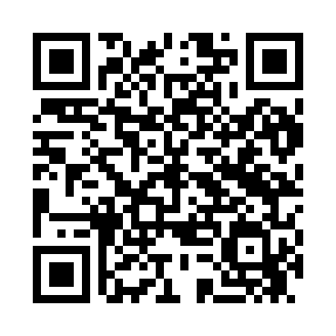

**Prayer times for Aavere, Estonia**

**Sun 1 Sep 2024 - Mon 30 Sep 2024**

**High Latitude Method: Angle Based Rule**

**Prayer Calculation Method: Muslim World League**

**Asar Calculation Method: Hanafi**

|  |  |  |  |  |  |  |  |
| --- | --- | --- | --- | --- | --- | --- | --- |
| **Date** | **Day** | **Fajr** | **Sunrise** | **Dhuhr** | **Asr** | **Maghrib** | **Isha** |
| 1 | Sun | 3:24 | 6:16 | 1:19 | 5:58 | 8:20 | 10:57 |
| 2 | Mon | 3:29 | 6:19 | 1:18 | 5:56 | 8:17 | 10:52 |
| 3 | Tue | 3:33 | 6:21 | 1:18 | 5:53 | 8:14 | 10:48 |
| 4 | Wed | 3:38 | 6:23 | 1:18 | 5:51 | 8:11 | 10:43 |
| 5 | Thu | 3:42 | 6:25 | 1:17 | 5:49 | 8:08 | 10:38 |
| 6 | Fri | 3:46 | 6:28 | 1:17 | 5:47 | 8:05 | 10:34 |
| 7 | Sat | 3:50 | 6:30 | 1:17 | 5:44 | 8:02 | 10:30 |
| 8 | Sun | 3:54 | 6:32 | 1:16 | 5:42 | 7:59 | 10:25 |
| 9 | Mon | 3:58 | 6:35 | 1:16 | 5:40 | 7:56 | 10:21 |
| 10 | Tue | 4:01 | 6:37 | 1:16 | 5:37 | 7:53 | 10:17 |
| 11 | Wed | 4:05 | 6:39 | 1:15 | 5:35 | 7:50 | 10:13 |
| 12 | Thu | 4:09 | 6:41 | 1:15 | 5:33 | 7:47 | 10:09 |
| 13 | Fri | 4:12 | 6:44 | 1:15 | 5:30 | 7:44 | 10:05 |
| 14 | Sat | 4:15 | 6:46 | 1:14 | 5:28 | 7:41 | 10:01 |
| 15 | Sun | 4:19 | 6:48 | 1:14 | 5:25 | 7:38 | 9:57 |
| 16 | Mon | 4:22 | 6:50 | 1:14 | 5:23 | 7:35 | 9:53 |
| 17 | Tue | 4:25 | 6:53 | 1:13 | 5:20 | 7:32 | 9:49 |
| 18 | Wed | 4:29 | 6:55 | 1:13 | 5:18 | 7:29 | 9:46 |
| 19 | Thu | 4:32 | 6:57 | 1:13 | 5:15 | 7:26 | 9:42 |
| 20 | Fri | 4:35 | 7:00 | 1:12 | 5:13 | 7:23 | 9:38 |
| 21 | Sat | 4:38 | 7:02 | 1:12 | 5:10 | 7:20 | 9:35 |
| 22 | Sun | 4:41 | 7:04 | 1:11 | 5:08 | 7:18 | 9:31 |
| 23 | Mon | 4:44 | 7:06 | 1:11 | 5:05 | 7:15 | 9:28 |
| 24 | Tue | 4:47 | 7:09 | 1:11 | 5:03 | 7:12 | 9:24 |
| 25 | Wed | 4:50 | 7:11 | 1:10 | 5:00 | 7:09 | 9:21 |
| 26 | Thu | 4:52 | 7:13 | 1:10 | 4:58 | 7:06 | 9:17 |
| 27 | Fri | 4:55 | 7:16 | 1:10 | 4:55 | 7:03 | 9:14 |
| 28 | Sat | 4:58 | 7:18 | 1:09 | 4:53 | 7:00 | 9:10 |
| 29 | Sun | 5:01 | 7:20 | 1:09 | 4:50 | 6:57 | 9:07 |
| 30 | Mon | 5:03 | 7:22 | 1:09 | 4:48 | 6:54 | 9:04 |

**Prayer times provided by https://www.salahtimes.com**