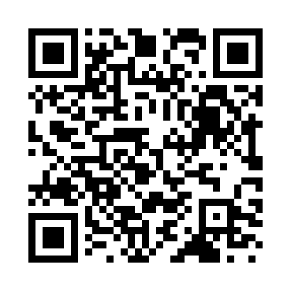
Prayer times for Albina, Italy
Wed 1 May 2024 - Fri 31 May 2024
High Latitude Method: Angle Based Rule
Prayer Calculation Method: Muslim World League
Asar Calculation Method: Hanafi

Date | Day | Fajr | Sunrise | Dhuhr | Asr | Maghrib | Isha
1 | Wed | 3:56 | 5:57 | 1:07 | 6:08 | 8:18 | 10:11
2 | Thu | 3:54 | 5:55 | 1:07 | 6:09 | 8:19 | 10:13
3 | Fri | 3:51 | 5:54 | 1:07 | 6:10 | 8:21 | 10:15
4 | Sat | 3:49 | 5:52 | 1:07 | 6:10 | 8:22 | 10:17
5 | Sun | 3:47 | 5:51 | 1:07 | 6:11 | 8:23 | 10:19
6 | Mon | 3:44 | 5:49 | 1:07 | 6:12 | 8:24 | 10:21
7 | Tue | 3:42 | 5:48 | 1:06 | 6:13 | 8:26 | 10:23
8 | Wed | 3:40 | 5:47 | 1:06 | 6:13 | 8:27 | 10:25
9 | Thu | 3:38 | 5:45 | 1:06 | 6:14 | 8:28 | 10:27
10 | Fri | 3:35 | 5:44 | 1:06 | 6:15 | 8:29 | 10:29
11 | Sat | 3:33 | 5:43 | 1:06 | 6:16 | 8:31 | 10:31
12 | Sun | 3:31 | 5:41 | 1:06 | 6:16 | 8:32 | 10:33
13 | Mon | 3:29 | 5:40 | 1:06 | 6:17 | 8:33 | 10:35
14 | Tue | 3:27 | 5:39 | 1:06 | 6:18 | 8:34 | 10:37
15 | Wed | 3:24 | 5:38 | 1:06 | 6:18 | 8:35 | 10:39
16 | Thu | 3:22 | 5:37 | 1:06 | 6:19 | 8:37 | 10:41
17 | Fri | 3:20 | 5:36 | 1:06 | 6:20 | 8:38 | 10:43
18 | Sat | 3:18 | 5:34 | 1:06 | 6:21 | 8:39 | 10:46
19 | Sun | 3:16 | 5:33 | 1:06 | 6:21 | 8:40 | 10:48
20 | Mon | 3:14 | 5:32 | 1:07 | 6:22 | 8:41 | 10:50
21 | Tue | 3:12 | 5:31 | 1:07 | 6:23 | 8:42 | 10:51
22 | Wed | 3:10 | 5:30 | 1:07 | 6:23 | 8:43 | 10:53
23 | Thu | 3:08 | 5:30 | 1:07 | 6:24 | 8:44 | 10:55
24 | Fri | 3:06 | 5:29 | 1:07 | 6:24 | 8:45 | 10:57
25 | Sat | 3:04 | 5:28 | 1:07 | 6:25 | 8:47 | 10:59
26 | Sun | 3:02 | 5:27 | 1:07 | 6:26 | 8:48 | 11:01
27 | Mon | 3:00 | 5:26 | 1:07 | 6:26 | 8:49 | 11:03
28 | Tue | 2:59 | 5:26 | 1:07 | 6:27 | 8:49 | 11:05
29 | Wed | 2:57 | 5:25 | 1:07 | 6:27 | 8:50 | 11:07
30 | Thu | 2:55 | 5:24 | 1:08 | 6:28 | 8:51 | 11:08
31 | Fri | 2:54 | 5:24 | 1:08 | 6:29 | 8:52 | 11:10
Prayer times provided by https://www.salahtimes.com

