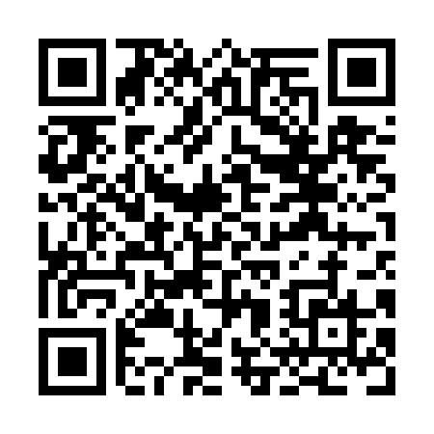
Prayer times for Devils Kitchen, Newfoundland and Labrador, Canada
Mon 1 Apr 2024 - Tue 30 Apr 2024
High Latitude Method: Angle Based Rule
Prayer Calculation Method: Islamic Society of North America
Asar Calculation Method: Hanafi

Date | Day | Fajr | Sunrise | Dhuhr | Asr | Maghrib | Isha
1 | Mon | 5:13 | 6:40 | 1:05 | 5:34 | 7:32 | 8:59
2 | Tue | 5:11 | 6:38 | 1:05 | 5:35 | 7:33 | 9:01
3 | Wed | 5:09 | 6:36 | 1:05 | 5:36 | 7:35 | 9:02
4 | Thu | 5:06 | 6:34 | 1:05 | 5:37 | 7:36 | 9:04
5 | Fri | 5:04 | 6:32 | 1:04 | 5:38 | 7:37 | 9:06
6 | Sat | 5:02 | 6:30 | 1:04 | 5:39 | 7:39 | 9:07
7 | Sun | 5:00 | 6:28 | 1:04 | 5:40 | 7:40 | 9:09
8 | Mon | 4:57 | 6:26 | 1:03 | 5:41 | 7:42 | 9:11
9 | Tue | 4:55 | 6:24 | 1:03 | 5:42 | 7:43 | 9:12
10 | Wed | 4:53 | 6:22 | 1:03 | 5:43 | 7:44 | 9:14
11 | Thu | 4:50 | 6:20 | 1:03 | 5:44 | 7:46 | 9:16
12 | Fri | 4:48 | 6:19 | 1:02 | 5:45 | 7:47 | 9:18
13 | Sat | 4:46 | 6:17 | 1:02 | 5:46 | 7:48 | 9:20
14 | Sun | 4:44 | 6:15 | 1:02 | 5:47 | 7:50 | 9:21
15 | Mon | 4:41 | 6:13 | 1:02 | 5:48 | 7:51 | 9:23
16 | Tue | 4:39 | 6:11 | 1:01 | 5:48 | 7:53 | 9:25
17 | Wed | 4:37 | 6:09 | 1:01 | 5:49 | 7:54 | 9:27
18 | Thu | 4:34 | 6:07 | 1:01 | 5:50 | 7:55 | 9:29
19 | Fri | 4:32 | 6:06 | 1:01 | 5:51 | 7:57 | 9:30
20 | Sat | 4:30 | 6:04 | 1:01 | 5:52 | 7:58 | 9:32
21 | Sun | 4:28 | 6:02 | 1:00 | 5:53 | 7:59 | 9:34
22 | Mon | 4:25 | 6:00 | 1:00 | 5:54 | 8:01 | 9:36
23 | Tue | 4:23 | 5:58 | 1:00 | 5:55 | 8:02 | 9:38
24 | Wed | 4:21 | 5:57 | 1:00 | 5:55 | 8:04 | 9:40
25 | Thu | 4:19 | 5:55 | 1:00 | 5:56 | 8:05 | 9:42
26 | Fri | 4:16 | 5:53 | 12:59 | 5:57 | 8:06 | 9:44
27 | Sat | 4:14 | 5:52 | 12:59 | 5:58 | 8:08 | 9:46
28 | Sun | 4:12 | 5:50 | 12:59 | 5:59 | 8:09 | 9:48
29 | Mon | 4:10 | 5:48 | 12:59 | 6:00 | 8:10 | 9:50
30 | Tue | 4:07 | 5:47 | 12:59 | 6:01 | 8:12 | 9:52
Prayer times provided by https://www.salahtimes.com

