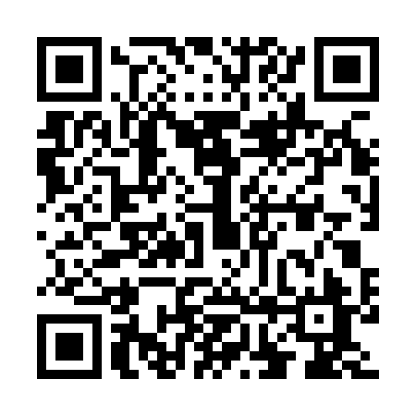
Prayer times for Kerelchar, Bangladesh
Mon 1 Apr 2024 - Tue 30 Apr 2024
High Latitude Method: None
Prayer Calculation Method: University of Islamic Sciences
Asar Calculation Method: Shafi

Date | Day | Fajr | Sunrise | Dhuhr | Asr | Maghrib | Isha
1 | Mon | 4:29 | 5:44 | 11:55 | 3:22 | 6:07 | 7:23
2 | Tue | 4:28 | 5:43 | 11:55 | 3:22 | 6:07 | 7:23
3 | Wed | 4:26 | 5:42 | 11:55 | 3:21 | 6:08 | 7:24
4 | Thu | 4:25 | 5:41 | 11:55 | 3:21 | 6:08 | 7:24
5 | Fri | 4:24 | 5:40 | 11:54 | 3:21 | 6:09 | 7:24
6 | Sat | 4:23 | 5:39 | 11:54 | 3:21 | 6:09 | 7:25
7 | Sun | 4:22 | 5:38 | 11:54 | 3:20 | 6:09 | 7:25
8 | Mon | 4:21 | 5:37 | 11:53 | 3:20 | 6:10 | 7:26
9 | Tue | 4:20 | 5:37 | 11:53 | 3:20 | 6:10 | 7:26
10 | Wed | 4:19 | 5:36 | 11:53 | 3:19 | 6:10 | 7:27
11 | Thu | 4:18 | 5:35 | 11:53 | 3:19 | 6:11 | 7:27
12 | Fri | 4:17 | 5:34 | 11:52 | 3:19 | 6:11 | 7:28
13 | Sat | 4:16 | 5:33 | 11:52 | 3:18 | 6:11 | 7:28
14 | Sun | 4:15 | 5:32 | 11:52 | 3:18 | 6:12 | 7:29
15 | Mon | 4:14 | 5:31 | 11:52 | 3:18 | 6:12 | 7:30
16 | Tue | 4:13 | 5:30 | 11:51 | 3:17 | 6:13 | 7:30
17 | Wed | 4:12 | 5:30 | 11:51 | 3:17 | 6:13 | 7:31
18 | Thu | 4:11 | 5:29 | 11:51 | 3:17 | 6:13 | 7:31
19 | Fri | 4:10 | 5:28 | 11:51 | 3:16 | 6:14 | 7:32
20 | Sat | 4:09 | 5:27 | 11:50 | 3:16 | 6:14 | 7:32
21 | Sun | 4:08 | 5:26 | 11:50 | 3:16 | 6:15 | 7:33
22 | Mon | 4:07 | 5:25 | 11:50 | 3:15 | 6:15 | 7:33
23 | Tue | 4:06 | 5:25 | 11:50 | 3:15 | 6:15 | 7:34
24 | Wed | 4:05 | 5:24 | 11:50 | 3:15 | 6:16 | 7:35
25 | Thu | 4:04 | 5:23 | 11:50 | 3:14 | 6:16 | 7:35
26 | Fri | 4:03 | 5:22 | 11:49 | 3:14 | 6:17 | 7:36
27 | Sat | 4:03 | 5:22 | 11:49 | 3:14 | 6:17 | 7:36
28 | Sun | 4:02 | 5:21 | 11:49 | 3:13 | 6:18 | 7:37
29 | Mon | 4:01 | 5:20 | 11:49 | 3:13 | 6:18 | 7:38
30 | Tue | 4:00 | 5:20 | 11:49 | 3:13 | 6:18 | 7:38
Prayer times provided by https://www.salahtimes.com

