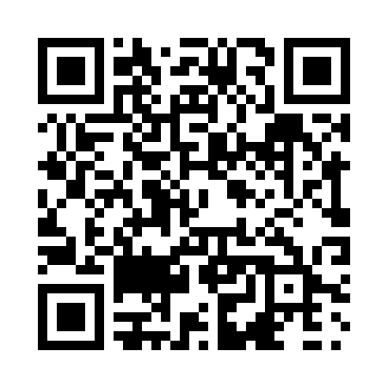
Prayer times for Smokey, Newfoundland and Labrador, Canada
Mon 1 Jul 2024 - Wed 31 Jul 2024
High Latitude Method: Angle Based Rule
Prayer Calculation Method: Islamic Society of North America
Asar Calculation Method: Hanafi

Date | Day | Fajr | Sunrise | Dhuhr | Asr | Maghrib | Isha
1 | Mon | 2:36 | 4:19 | 12:53 | 6:36 | 9:27 | 11:10
2 | Tue | 2:36 | 4:19 | 12:53 | 6:36 | 9:26 | 11:10
3 | Wed | 2:37 | 4:20 | 12:53 | 6:36 | 9:26 | 11:09
4 | Thu | 2:37 | 4:21 | 12:53 | 6:35 | 9:25 | 11:09
5 | Fri | 2:38 | 4:22 | 12:53 | 6:35 | 9:24 | 11:09
6 | Sat | 2:38 | 4:23 | 12:54 | 6:35 | 9:24 | 11:09
7 | Sun | 2:39 | 4:24 | 12:54 | 6:35 | 9:23 | 11:08
8 | Mon | 2:40 | 4:25 | 12:54 | 6:34 | 9:22 | 11:08
9 | Tue | 2:40 | 4:26 | 12:54 | 6:34 | 9:21 | 11:08
10 | Wed | 2:41 | 4:28 | 12:54 | 6:33 | 9:20 | 11:07
11 | Thu | 2:41 | 4:29 | 12:54 | 6:33 | 9:19 | 11:07
12 | Fri | 2:42 | 4:30 | 12:54 | 6:33 | 9:18 | 11:06
13 | Sat | 2:43 | 4:31 | 12:55 | 6:32 | 9:17 | 11:06
14 | Sun | 2:44 | 4:33 | 12:55 | 6:31 | 9:16 | 11:05
15 | Mon | 2:44 | 4:34 | 12:55 | 6:31 | 9:15 | 11:05
16 | Tue | 2:45 | 4:36 | 12:55 | 6:30 | 9:14 | 11:04
17 | Wed | 2:46 | 4:37 | 12:55 | 6:30 | 9:12 | 11:03
18 | Thu | 2:47 | 4:38 | 12:55 | 6:29 | 9:11 | 11:03
19 | Fri | 2:47 | 4:40 | 12:55 | 6:28 | 9:10 | 11:02
20 | Sat | 2:48 | 4:41 | 12:55 | 6:27 | 9:08 | 11:01
21 | Sun | 2:49 | 4:43 | 12:55 | 6:27 | 9:07 | 11:01
22 | Mon | 2:50 | 4:45 | 12:55 | 6:26 | 9:05 | 11:00
23 | Tue | 2:50 | 4:46 | 12:55 | 6:25 | 9:04 | 10:59
24 | Wed | 2:51 | 4:48 | 12:55 | 6:24 | 9:02 | 10:58
25 | Thu | 2:52 | 4:49 | 12:55 | 6:23 | 9:00 | 10:58
26 | Fri | 2:53 | 4:51 | 12:55 | 6:22 | 8:59 | 10:57
27 | Sat | 2:54 | 4:53 | 12:55 | 6:21 | 8:57 | 10:56
28 | Sun | 2:55 | 4:54 | 12:55 | 6:20 | 8:55 | 10:55
29 | Mon | 2:55 | 4:56 | 12:55 | 6:19 | 8:54 | 10:54
30 | Tue | 2:56 | 4:58 | 12:55 | 6:18 | 8:52 | 10:53
31 | Wed | 2:57 | 4:59 | 12:55 | 6:17 | 8:50 | 10:52
Prayer times provided by https://www.salahtimes.com

