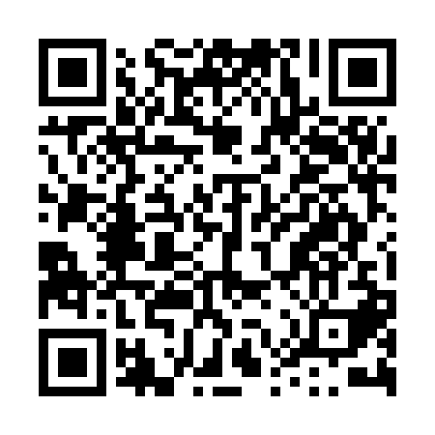

**Prayer times for Andra Mari Ermita, Spain**

**Wed 1 Jan 2025 - Fri 31 Jan 2025**

**High Latitude Method: Angle Based Rule**

**Prayer Calculation Method: Muslim World League**

**Asar Calculation Method: Hanafi**

|  |  |  |  |  |  |  |  |
| --- | --- | --- | --- | --- | --- | --- | --- |
| **Date** | **Day** | **Fajr** | **Sunrise** | **Dhuhr** | **Asr** | **Maghrib** | **Isha** |
| 1 | Wed | 6:58 | 8:41 | 1:13 | 4:02 | 5:44 | 7:21 |
| 2 | Thu | 6:59 | 8:41 | 1:13 | 4:03 | 5:45 | 7:22 |
| 3 | Fri | 6:59 | 8:41 | 1:14 | 4:04 | 5:46 | 7:23 |
| 4 | Sat | 6:59 | 8:41 | 1:14 | 4:05 | 5:47 | 7:24 |
| 5 | Sun | 6:59 | 8:41 | 1:15 | 4:06 | 5:48 | 7:25 |
| 6 | Mon | 6:59 | 8:41 | 1:15 | 4:07 | 5:49 | 7:26 |
| 7 | Tue | 6:59 | 8:41 | 1:15 | 4:08 | 5:50 | 7:27 |
| 8 | Wed | 6:59 | 8:41 | 1:16 | 4:09 | 5:51 | 7:28 |
| 9 | Thu | 6:59 | 8:41 | 1:16 | 4:10 | 5:52 | 7:28 |
| 10 | Fri | 6:59 | 8:40 | 1:17 | 4:11 | 5:53 | 7:29 |
| 11 | Sat | 6:58 | 8:40 | 1:17 | 4:12 | 5:54 | 7:30 |
| 12 | Sun | 6:58 | 8:40 | 1:17 | 4:13 | 5:56 | 7:31 |
| 13 | Mon | 6:58 | 8:39 | 1:18 | 4:14 | 5:57 | 7:32 |
| 14 | Tue | 6:58 | 8:39 | 1:18 | 4:16 | 5:58 | 7:33 |
| 15 | Wed | 6:57 | 8:38 | 1:19 | 4:17 | 5:59 | 7:34 |
| 16 | Thu | 6:57 | 8:38 | 1:19 | 4:18 | 6:00 | 7:36 |
| 17 | Fri | 6:57 | 8:37 | 1:19 | 4:19 | 6:02 | 7:37 |
| 18 | Sat | 6:56 | 8:37 | 1:20 | 4:20 | 6:03 | 7:38 |
| 19 | Sun | 6:56 | 8:36 | 1:20 | 4:22 | 6:04 | 7:39 |
| 20 | Mon | 6:55 | 8:35 | 1:20 | 4:23 | 6:05 | 7:40 |
| 21 | Tue | 6:55 | 8:35 | 1:20 | 4:24 | 6:07 | 7:41 |
| 22 | Wed | 6:54 | 8:34 | 1:21 | 4:25 | 6:08 | 7:42 |
| 23 | Thu | 6:54 | 8:33 | 1:21 | 4:27 | 6:09 | 7:43 |
| 24 | Fri | 6:53 | 8:32 | 1:21 | 4:28 | 6:11 | 7:44 |
| 25 | Sat | 6:52 | 8:31 | 1:21 | 4:29 | 6:12 | 7:45 |
| 26 | Sun | 6:52 | 8:31 | 1:22 | 4:31 | 6:13 | 7:47 |
| 27 | Mon | 6:51 | 8:30 | 1:22 | 4:32 | 6:15 | 7:48 |
| 28 | Tue | 6:50 | 8:29 | 1:22 | 4:33 | 6:16 | 7:49 |
| 29 | Wed | 6:49 | 8:28 | 1:22 | 4:34 | 6:17 | 7:50 |
| 30 | Thu | 6:49 | 8:27 | 1:22 | 4:36 | 6:19 | 7:51 |
| 31 | Fri | 6:48 | 8:26 | 1:22 | 4:37 | 6:20 | 7:52 |

**Prayer times provided by https://www.salahtimes.com**