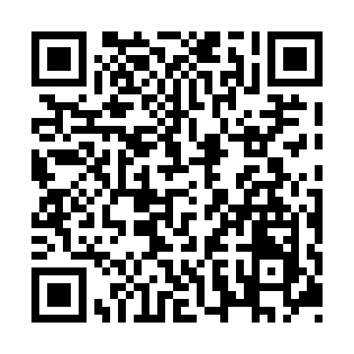
Prayer times for Coachman's Cove, Newfoundland and Labrador, Canada
Mon 1 Apr 2024 - Tue 30 Apr 2024
High Latitude Method: Angle Based Rule
Prayer Calculation Method: Islamic Society of North America
Asar Calculation Method: Hanafi

Date | Day | Fajr | Sunrise | Dhuhr | Asr | Maghrib | Isha
1 | Mon | 5:17 | 6:50 | 1:18 | 5:46 | 7:47 | 9:21
2 | Tue | 5:14 | 6:48 | 1:18 | 5:47 | 7:49 | 9:22
3 | Wed | 5:12 | 6:46 | 1:18 | 5:48 | 7:50 | 9:24
4 | Thu | 5:09 | 6:43 | 1:17 | 5:50 | 7:52 | 9:26
5 | Fri | 5:07 | 6:41 | 1:17 | 5:51 | 7:54 | 9:28
6 | Sat | 5:04 | 6:39 | 1:17 | 5:52 | 7:55 | 9:30
7 | Sun | 5:02 | 6:37 | 1:16 | 5:53 | 7:57 | 9:32
8 | Mon | 4:59 | 6:35 | 1:16 | 5:54 | 7:58 | 9:34
9 | Tue | 4:57 | 6:33 | 1:16 | 5:55 | 8:00 | 9:36
10 | Wed | 4:54 | 6:31 | 1:16 | 5:56 | 8:01 | 9:38
11 | Thu | 4:52 | 6:29 | 1:15 | 5:57 | 8:03 | 9:40
12 | Fri | 4:49 | 6:27 | 1:15 | 5:58 | 8:05 | 9:43
13 | Sat | 4:46 | 6:24 | 1:15 | 5:59 | 8:06 | 9:45
14 | Sun | 4:44 | 6:22 | 1:15 | 6:00 | 8:08 | 9:47
15 | Mon | 4:41 | 6:20 | 1:14 | 6:01 | 8:09 | 9:49
16 | Tue | 4:39 | 6:18 | 1:14 | 6:02 | 8:11 | 9:51
17 | Wed | 4:36 | 6:16 | 1:14 | 6:04 | 8:12 | 9:53
18 | Thu | 4:33 | 6:14 | 1:14 | 6:05 | 8:14 | 9:55
19 | Fri | 4:31 | 6:12 | 1:13 | 6:06 | 8:16 | 9:58
20 | Sat | 4:28 | 6:10 | 1:13 | 6:07 | 8:17 | 10:00
21 | Sun | 4:25 | 6:08 | 1:13 | 6:08 | 8:19 | 10:02
22 | Mon | 4:23 | 6:06 | 1:13 | 6:09 | 8:20 | 10:04
23 | Tue | 4:20 | 6:04 | 1:13 | 6:10 | 8:22 | 10:07
24 | Wed | 4:18 | 6:03 | 1:13 | 6:11 | 8:23 | 10:09
25 | Thu | 4:15 | 6:01 | 1:12 | 6:12 | 8:25 | 10:11
26 | Fri | 4:12 | 5:59 | 1:12 | 6:13 | 8:27 | 10:13
27 | Sat | 4:10 | 5:57 | 1:12 | 6:14 | 8:28 | 10:16
28 | Sun | 4:07 | 5:55 | 1:12 | 6:15 | 8:30 | 10:18
29 | Mon | 4:04 | 5:53 | 1:12 | 6:15 | 8:31 | 10:20
30 | Tue | 4:02 | 5:51 | 1:12 | 6:16 | 8:33 | 10:23
Prayer times provided by https://www.salahtimes.com

