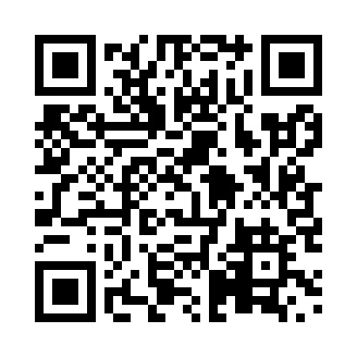

**Prayer times for Hawk Hills, Alberta, Canada**

**Sun 1 Sep 2024 - Mon 30 Sep 2024**

**High Latitude Method: Angle Based Rule**

**Prayer Calculation Method: Islamic Society of North America**

**Asar Calculation Method: Hanafi**

|  |  |  |  |  |  |  |  |
| --- | --- | --- | --- | --- | --- | --- | --- |
| **Date** | **Day** | **Fajr** | **Sunrise** | **Dhuhr** | **Asr** | **Maghrib** | **Isha** |
| 1 | Sun | 4:52 | 6:53 | 1:49 | 6:28 | 8:45 | 10:46 |
| 2 | Mon | 4:55 | 6:55 | 1:49 | 6:26 | 8:42 | 10:42 |
| 3 | Tue | 4:58 | 6:57 | 1:49 | 6:24 | 8:39 | 10:38 |
| 4 | Wed | 5:00 | 6:59 | 1:48 | 6:22 | 8:37 | 10:35 |
| 5 | Thu | 5:03 | 7:01 | 1:48 | 6:20 | 8:34 | 10:31 |
| 6 | Fri | 5:06 | 7:03 | 1:48 | 6:18 | 8:31 | 10:28 |
| 7 | Sat | 5:09 | 7:05 | 1:47 | 6:15 | 8:28 | 10:24 |
| 8 | Sun | 5:12 | 7:07 | 1:47 | 6:13 | 8:26 | 10:21 |
| 9 | Mon | 5:15 | 7:09 | 1:47 | 6:11 | 8:23 | 10:17 |
| 10 | Tue | 5:17 | 7:11 | 1:46 | 6:09 | 8:20 | 10:14 |
| 11 | Wed | 5:20 | 7:13 | 1:46 | 6:07 | 8:17 | 10:10 |
| 12 | Thu | 5:23 | 7:16 | 1:46 | 6:04 | 8:15 | 10:07 |
| 13 | Fri | 5:25 | 7:18 | 1:45 | 6:02 | 8:12 | 10:04 |
| 14 | Sat | 5:28 | 7:20 | 1:45 | 6:00 | 8:09 | 10:00 |
| 15 | Sun | 5:31 | 7:22 | 1:45 | 5:57 | 8:06 | 9:57 |
| 16 | Mon | 5:33 | 7:24 | 1:44 | 5:55 | 8:04 | 9:54 |
| 17 | Tue | 5:36 | 7:26 | 1:44 | 5:53 | 8:01 | 9:51 |
| 18 | Wed | 5:38 | 7:28 | 1:44 | 5:51 | 7:58 | 9:47 |
| 19 | Thu | 5:41 | 7:30 | 1:43 | 5:48 | 7:55 | 9:44 |
| 20 | Fri | 5:43 | 7:32 | 1:43 | 5:46 | 7:52 | 9:41 |
| 21 | Sat | 5:46 | 7:34 | 1:42 | 5:44 | 7:50 | 9:38 |
| 22 | Sun | 5:48 | 7:36 | 1:42 | 5:41 | 7:47 | 9:35 |
| 23 | Mon | 5:50 | 7:38 | 1:42 | 5:39 | 7:44 | 9:32 |
| 24 | Tue | 5:53 | 7:40 | 1:41 | 5:37 | 7:41 | 9:29 |
| 25 | Wed | 5:55 | 7:42 | 1:41 | 5:34 | 7:39 | 9:26 |
| 26 | Thu | 5:57 | 7:44 | 1:41 | 5:32 | 7:36 | 9:23 |
| 27 | Fri | 6:00 | 7:47 | 1:40 | 5:29 | 7:33 | 9:20 |
| 28 | Sat | 6:02 | 7:49 | 1:40 | 5:27 | 7:30 | 9:17 |
| 29 | Sun | 6:04 | 7:51 | 1:40 | 5:25 | 7:28 | 9:14 |
| 30 | Mon | 6:07 | 7:53 | 1:39 | 5:22 | 7:25 | 9:11 |

**Prayer times provided by https://www.salahtimes.com**