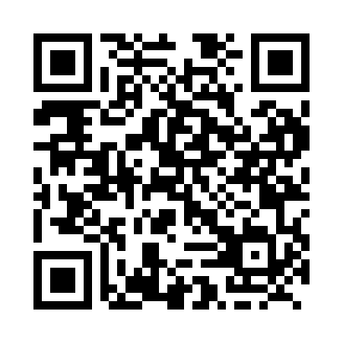
Prayer times for Doting Cove, Newfoundland and Labrador, Canada
Mon 1 Jul 2024 - Wed 31 Jul 2024
High Latitude Method: Angle Based Rule
Prayer Calculation Method: Islamic Society of North America
Asar Calculation Method: Hanafi

Date | Day | Fajr | Sunrise | Dhuhr | Asr | Maghrib | Isha
1 | Mon | 3:07 | 5:04 | 1:10 | 6:41 | 9:15 | 11:12
2 | Tue | 3:07 | 5:05 | 1:10 | 6:41 | 9:15 | 11:12
3 | Wed | 3:08 | 5:05 | 1:10 | 6:41 | 9:15 | 11:12
4 | Thu | 3:08 | 5:06 | 1:10 | 6:41 | 9:14 | 11:12
5 | Fri | 3:09 | 5:07 | 1:10 | 6:41 | 9:14 | 11:12
6 | Sat | 3:09 | 5:08 | 1:11 | 6:40 | 9:13 | 11:12
7 | Sun | 3:10 | 5:09 | 1:11 | 6:40 | 9:13 | 11:12
8 | Mon | 3:10 | 5:09 | 1:11 | 6:40 | 9:12 | 11:11
9 | Tue | 3:11 | 5:10 | 1:11 | 6:40 | 9:11 | 11:11
10 | Wed | 3:11 | 5:11 | 1:11 | 6:39 | 9:11 | 11:11
11 | Thu | 3:12 | 5:12 | 1:11 | 6:39 | 9:10 | 11:11
12 | Fri | 3:12 | 5:13 | 1:11 | 6:39 | 9:09 | 11:10
13 | Sat | 3:13 | 5:14 | 1:12 | 6:38 | 9:08 | 11:10
14 | Sun | 3:13 | 5:15 | 1:12 | 6:38 | 9:08 | 11:10
15 | Mon | 3:14 | 5:16 | 1:12 | 6:37 | 9:07 | 11:09
16 | Tue | 3:15 | 5:18 | 1:12 | 6:37 | 9:06 | 11:09
17 | Wed | 3:15 | 5:19 | 1:12 | 6:36 | 9:05 | 11:08
18 | Thu | 3:16 | 5:20 | 1:12 | 6:36 | 9:04 | 11:08
19 | Fri | 3:16 | 5:21 | 1:12 | 6:35 | 9:03 | 11:07
20 | Sat | 3:17 | 5:22 | 1:12 | 6:35 | 9:02 | 11:07
21 | Sun | 3:18 | 5:23 | 1:12 | 6:34 | 9:00 | 11:06
22 | Mon | 3:18 | 5:25 | 1:12 | 6:34 | 8:59 | 11:05
23 | Tue | 3:21 | 5:26 | 1:12 | 6:33 | 8:58 | 11:03
24 | Wed | 3:23 | 5:27 | 1:12 | 6:32 | 8:57 | 11:00
25 | Thu | 3:25 | 5:29 | 1:12 | 6:31 | 8:55 | 10:58
26 | Fri | 3:28 | 5:30 | 1:12 | 6:31 | 8:54 | 10:56
27 | Sat | 3:30 | 5:31 | 1:12 | 6:30 | 8:53 | 10:53
28 | Sun | 3:32 | 5:32 | 1:12 | 6:29 | 8:51 | 10:51
29 | Mon | 3:35 | 5:34 | 1:12 | 6:28 | 8:50 | 10:48
30 | Tue | 3:37 | 5:35 | 1:12 | 6:27 | 8:48 | 10:46
31 | Wed | 3:39 | 5:37 | 1:12 | 6:26 | 8:47 | 10:44
Prayer times provided by https://www.salahtimes.com

