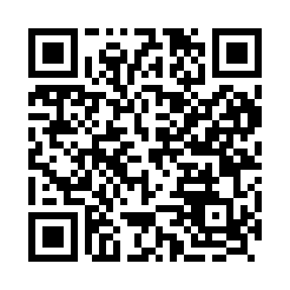

**Prayer times for Bedsted, Denmark**

**Sun 1 Sep 2024 - Mon 30 Sep 2024**

**High Latitude Method: Angle Based Rule**

**Prayer Calculation Method: Muslim World League**

**Asar Calculation Method: Hanafi**

|  |  |  |  |  |  |  |  |
| --- | --- | --- | --- | --- | --- | --- | --- |
| **Date** | **Day** | **Fajr** | **Sunrise** | **Dhuhr** | **Asr** | **Maghrib** | **Isha** |
| 1 | Sun | 3:58 | 6:30 | 1:26 | 6:06 | 8:21 | 10:41 |
| 2 | Mon | 4:02 | 6:32 | 1:26 | 6:03 | 8:19 | 10:37 |
| 3 | Tue | 4:05 | 6:34 | 1:26 | 6:01 | 8:16 | 10:33 |
| 4 | Wed | 4:09 | 6:36 | 1:25 | 5:59 | 8:13 | 10:29 |
| 5 | Thu | 4:12 | 6:38 | 1:25 | 5:57 | 8:11 | 10:26 |
| 6 | Fri | 4:15 | 6:40 | 1:25 | 5:55 | 8:08 | 10:22 |
| 7 | Sat | 4:18 | 6:42 | 1:24 | 5:53 | 8:05 | 10:18 |
| 8 | Sun | 4:22 | 6:44 | 1:24 | 5:51 | 8:03 | 10:15 |
| 9 | Mon | 4:25 | 6:46 | 1:24 | 5:49 | 8:00 | 10:11 |
| 10 | Tue | 4:28 | 6:48 | 1:23 | 5:46 | 7:57 | 10:08 |
| 11 | Wed | 4:31 | 6:50 | 1:23 | 5:44 | 7:54 | 10:04 |
| 12 | Thu | 4:33 | 6:52 | 1:22 | 5:42 | 7:52 | 10:01 |
| 13 | Fri | 4:36 | 6:54 | 1:22 | 5:40 | 7:49 | 9:57 |
| 14 | Sat | 4:39 | 6:56 | 1:22 | 5:38 | 7:46 | 9:54 |
| 15 | Sun | 4:42 | 6:58 | 1:21 | 5:35 | 7:44 | 9:50 |
| 16 | Mon | 4:45 | 7:00 | 1:21 | 5:33 | 7:41 | 9:47 |
| 17 | Tue | 4:47 | 7:02 | 1:21 | 5:31 | 7:38 | 9:44 |
| 18 | Wed | 4:50 | 7:04 | 1:20 | 5:29 | 7:35 | 9:40 |
| 19 | Thu | 4:53 | 7:06 | 1:20 | 5:26 | 7:33 | 9:37 |
| 20 | Fri | 4:55 | 7:08 | 1:20 | 5:24 | 7:30 | 9:34 |
| 21 | Sat | 4:58 | 7:10 | 1:19 | 5:22 | 7:27 | 9:31 |
| 22 | Sun | 5:01 | 7:12 | 1:19 | 5:19 | 7:24 | 9:27 |
| 23 | Mon | 5:03 | 7:14 | 1:19 | 5:17 | 7:22 | 9:24 |
| 24 | Tue | 5:06 | 7:16 | 1:18 | 5:15 | 7:19 | 9:21 |
| 25 | Wed | 5:08 | 7:18 | 1:18 | 5:12 | 7:16 | 9:18 |
| 26 | Thu | 5:11 | 7:20 | 1:18 | 5:10 | 7:14 | 9:15 |
| 27 | Fri | 5:13 | 7:22 | 1:17 | 5:08 | 7:11 | 9:12 |
| 28 | Sat | 5:15 | 7:24 | 1:17 | 5:05 | 7:08 | 9:09 |
| 29 | Sun | 5:18 | 7:26 | 1:17 | 5:03 | 7:05 | 9:06 |
| 30 | Mon | 5:20 | 7:29 | 1:16 | 5:01 | 7:03 | 9:03 |

**Prayer times provided by https://www.salahtimes.com**