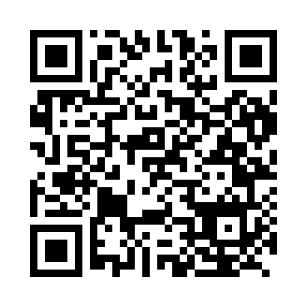

**Prayer times for Kucha, China**

**Wed 1 Jan 2025 - Fri 31 Jan 2025**

**High Latitude Method: Angle Based Rule**

**Prayer Calculation Method: Muslim World League**

**Asar Calculation Method: Shafi**

|  |  |  |  |  |  |  |  |
| --- | --- | --- | --- | --- | --- | --- | --- |
| **Date** | **Day** | **Fajr** | **Sunrise** | **Dhuhr** | **Asr** | **Maghrib** | **Isha** |
| 1 | Wed | 8:15 | 9:55 | 2:32 | 4:50 | 7:08 | 8:43 |
| 2 | Thu | 8:15 | 9:55 | 2:32 | 4:51 | 7:09 | 8:44 |
| 3 | Fri | 8:16 | 9:55 | 2:33 | 4:52 | 7:10 | 8:44 |
| 4 | Sat | 8:16 | 9:55 | 2:33 | 4:53 | 7:11 | 8:45 |
| 5 | Sun | 8:16 | 9:55 | 2:34 | 4:54 | 7:12 | 8:46 |
| 6 | Mon | 8:16 | 9:55 | 2:34 | 4:55 | 7:13 | 8:47 |
| 7 | Tue | 8:16 | 9:55 | 2:34 | 4:55 | 7:14 | 8:48 |
| 8 | Wed | 8:16 | 9:55 | 2:35 | 4:56 | 7:15 | 8:49 |
| 9 | Thu | 8:16 | 9:55 | 2:35 | 4:57 | 7:16 | 8:50 |
| 10 | Fri | 8:16 | 9:55 | 2:36 | 4:58 | 7:17 | 8:51 |
| 11 | Sat | 8:16 | 9:54 | 2:36 | 4:59 | 7:18 | 8:51 |
| 12 | Sun | 8:15 | 9:54 | 2:37 | 5:00 | 7:19 | 8:52 |
| 13 | Mon | 8:15 | 9:54 | 2:37 | 5:01 | 7:20 | 8:53 |
| 14 | Tue | 8:15 | 9:53 | 2:37 | 5:02 | 7:22 | 8:54 |
| 15 | Wed | 8:15 | 9:53 | 2:38 | 5:03 | 7:23 | 8:55 |
| 16 | Thu | 8:14 | 9:53 | 2:38 | 5:04 | 7:24 | 8:56 |
| 17 | Fri | 8:14 | 9:52 | 2:38 | 5:05 | 7:25 | 8:57 |
| 18 | Sat | 8:14 | 9:51 | 2:39 | 5:06 | 7:26 | 8:58 |
| 19 | Sun | 8:13 | 9:51 | 2:39 | 5:07 | 7:27 | 8:59 |
| 20 | Mon | 8:13 | 9:50 | 2:39 | 5:08 | 7:29 | 9:00 |
| 21 | Tue | 8:12 | 9:50 | 2:40 | 5:09 | 7:30 | 9:02 |
| 22 | Wed | 8:12 | 9:49 | 2:40 | 5:10 | 7:31 | 9:03 |
| 23 | Thu | 8:11 | 9:48 | 2:40 | 5:12 | 7:32 | 9:04 |
| 24 | Fri | 8:11 | 9:48 | 2:40 | 5:13 | 7:33 | 9:05 |
| 25 | Sat | 8:10 | 9:47 | 2:41 | 5:14 | 7:35 | 9:06 |
| 26 | Sun | 8:10 | 9:46 | 2:41 | 5:15 | 7:36 | 9:07 |
| 27 | Mon | 8:09 | 9:45 | 2:41 | 5:16 | 7:37 | 9:08 |
| 28 | Tue | 8:08 | 9:44 | 2:41 | 5:17 | 7:39 | 9:09 |
| 29 | Wed | 8:08 | 9:43 | 2:41 | 5:18 | 7:40 | 9:10 |
| 30 | Thu | 8:07 | 9:42 | 2:41 | 5:19 | 7:41 | 9:11 |
| 31 | Fri | 8:06 | 9:41 | 2:42 | 5:20 | 7:42 | 9:12 |

**Prayer times provided by https://www.salahtimes.com**