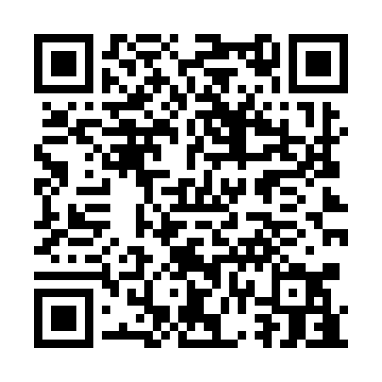
Prayer times for Ilirska Bistrica, Slovenia
Mon 1 Apr 2024 - Tue 30 Apr 2024
High Latitude Method: Angle Based Rule
Prayer Calculation Method: Muslim World League
Asar Calculation Method: Hanafi

Date | Day | Fajr | Sunrise | Dhuhr | Asr | Maghrib | Isha
1 | Mon | 5:00 | 6:43 | 1:07 | 5:36 | 7:32 | 9:09
2 | Tue | 4:57 | 6:41 | 1:06 | 5:37 | 7:33 | 9:10
3 | Wed | 4:55 | 6:39 | 1:06 | 5:38 | 7:34 | 9:12
4 | Thu | 4:53 | 6:37 | 1:06 | 5:39 | 7:36 | 9:13
5 | Fri | 4:51 | 6:35 | 1:06 | 5:39 | 7:37 | 9:15
6 | Sat | 4:48 | 6:33 | 1:05 | 5:40 | 7:38 | 9:17
7 | Sun | 4:46 | 6:31 | 1:05 | 5:41 | 7:39 | 9:18
8 | Mon | 4:44 | 6:30 | 1:05 | 5:42 | 7:41 | 9:20
9 | Tue | 4:42 | 6:28 | 1:04 | 5:43 | 7:42 | 9:22
10 | Wed | 4:39 | 6:26 | 1:04 | 5:44 | 7:43 | 9:23
11 | Thu | 4:37 | 6:24 | 1:04 | 5:45 | 7:45 | 9:25
12 | Fri | 4:35 | 6:22 | 1:04 | 5:46 | 7:46 | 9:27
13 | Sat | 4:32 | 6:20 | 1:03 | 5:46 | 7:47 | 9:29
14 | Sun | 4:30 | 6:19 | 1:03 | 5:47 | 7:49 | 9:30
15 | Mon | 4:28 | 6:17 | 1:03 | 5:48 | 7:50 | 9:32
16 | Tue | 4:26 | 6:15 | 1:03 | 5:49 | 7:51 | 9:34
17 | Wed | 4:23 | 6:13 | 1:03 | 5:50 | 7:52 | 9:36
18 | Thu | 4:21 | 6:12 | 1:02 | 5:51 | 7:54 | 9:38
19 | Fri | 4:19 | 6:10 | 1:02 | 5:51 | 7:55 | 9:39
20 | Sat | 4:16 | 6:08 | 1:02 | 5:52 | 7:56 | 9:41
21 | Sun | 4:14 | 6:07 | 1:02 | 5:53 | 7:58 | 9:43
22 | Mon | 4:12 | 6:05 | 1:01 | 5:54 | 7:59 | 9:45
23 | Tue | 4:09 | 6:03 | 1:01 | 5:55 | 8:00 | 9:47
24 | Wed | 4:07 | 6:02 | 1:01 | 5:55 | 8:01 | 9:49
25 | Thu | 4:05 | 6:00 | 1:01 | 5:56 | 8:03 | 9:51
26 | Fri | 4:02 | 5:58 | 1:01 | 5:57 | 8:04 | 9:53
27 | Sat | 4:00 | 5:57 | 1:01 | 5:58 | 8:05 | 9:54
28 | Sun | 3:58 | 5:55 | 1:00 | 5:59 | 8:07 | 9:56
29 | Mon | 3:56 | 5:54 | 1:00 | 5:59 | 8:08 | 9:58
30 | Tue | 3:53 | 5:52 | 1:00 | 6:00 | 8:09 | 10:00
Prayer times provided by https://www.salahtimes.com

