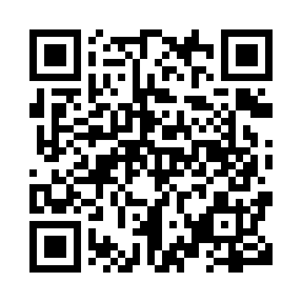
Prayer times for Keno Hill, Yukon, Canada
Wed 1 May 2024 - Fri 31 May 2024
High Latitude Method: Angle Based Rule
Prayer Calculation Method: Islamic Society of North America
Asar Calculation Method: Hanafi

Date | Day | Fajr | Sunrise | Dhuhr | Asr | Maghrib | Isha
1 | Wed | 3:46 | 5:32 | 1:58 | 7:23 | 10:26 | 12:12
2 | Thu | 3:44 | 5:29 | 1:58 | 7:24 | 10:29 | 12:14
3 | Fri | 3:42 | 5:25 | 1:58 | 7:26 | 10:32 | 12:16
4 | Sat | 3:40 | 5:22 | 1:58 | 7:28 | 10:35 | 12:17
5 | Sun | 3:39 | 5:19 | 1:58 | 7:30 | 10:39 | 12:19
6 | Mon | 3:37 | 5:15 | 1:58 | 7:31 | 10:42 | 12:20
7 | Tue | 3:35 | 5:12 | 1:58 | 7:33 | 10:45 | 12:22
8 | Wed | 3:34 | 5:09 | 1:58 | 7:34 | 10:48 | 12:23
9 | Thu | 3:32 | 5:06 | 1:58 | 7:36 | 10:51 | 12:25
10 | Fri | 3:30 | 5:02 | 1:58 | 7:38 | 10:55 | 12:26
11 | Sat | 3:29 | 4:59 | 1:58 | 7:39 | 10:58 | 12:28
12 | Sun | 3:27 | 4:56 | 1:58 | 7:41 | 11:01 | 12:30
13 | Mon | 3:25 | 4:53 | 1:58 | 7:42 | 11:04 | 12:31
14 | Tue | 3:24 | 4:49 | 1:58 | 7:44 | 11:07 | 12:33
15 | Wed | 3:22 | 4:46 | 1:58 | 7:45 | 11:11 | 12:34
16 | Thu | 3:21 | 4:43 | 1:58 | 7:47 | 11:14 | 12:36
17 | Fri | 3:19 | 4:40 | 1:58 | 7:48 | 11:17 | 12:38
18 | Sat | 3:18 | 4:37 | 1:58 | 7:49 | 11:20 | 12:39
19 | Sun | 3:16 | 4:34 | 1:58 | 7:51 | 11:23 | 12:41
20 | Mon | 3:15 | 4:31 | 1:58 | 7:52 | 11:26 | 12:42
21 | Tue | 3:13 | 4:28 | 1:58 | 7:54 | 11:29 | 12:44
22 | Wed | 3:12 | 4:25 | 1:58 | 7:55 | 11:32 | 12:46
23 | Thu | 3:10 | 4:22 | 1:58 | 7:56 | 11:36 | 12:47
24 | Fri | 3:09 | 4:19 | 1:58 | 7:57 | 11:39 | 12:49
25 | Sat | 3:08 | 4:16 | 1:58 | 7:59 | 11:42 | 12:50
26 | Sun | 3:06 | 4:14 | 1:58 | 8:00 | 11:45 | 12:52
27 | Mon | 3:05 | 4:11 | 1:58 | 8:01 | 11:47 | 12:53
28 | Tue | 3:04 | 4:08 | 1:59 | 8:02 | 11:50 | 12:55
29 | Wed | 3:03 | 4:06 | 1:59 | 8:03 | 11:53 | 12:56
30 | Thu | 3:01 | 4:03 | 1:59 | 8:04 | 11:56 | 12:58
31 | Fri | 3:00 | 4:01 | 1:59 | 8:05 | 11:59 | 12:59
Prayer times provided by https://www.salahtimes.com

