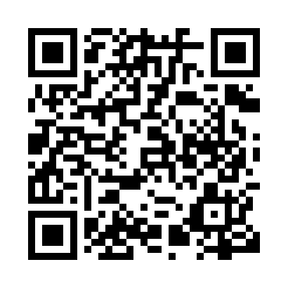

**Prayer times for Furman, Alberta, Canada**

**Sun 1 Sep 2024 - Mon 30 Sep 2024**

**High Latitude Method: Angle Based Rule**

**Prayer Calculation Method: Islamic Society of North America**

**Asar Calculation Method: Hanafi**

|  |  |  |  |  |  |  |  |
| --- | --- | --- | --- | --- | --- | --- | --- |
| **Date** | **Day** | **Fajr** | **Sunrise** | **Dhuhr** | **Asr** | **Maghrib** | **Isha** |
| 1 | Sun | 5:16 | 6:52 | 1:36 | 6:15 | 8:18 | 9:54 |
| 2 | Mon | 5:18 | 6:54 | 1:35 | 6:13 | 8:16 | 9:52 |
| 3 | Tue | 5:20 | 6:55 | 1:35 | 6:11 | 8:14 | 9:49 |
| 4 | Wed | 5:22 | 6:57 | 1:35 | 6:10 | 8:12 | 9:47 |
| 5 | Thu | 5:24 | 6:58 | 1:34 | 6:08 | 8:10 | 9:44 |
| 6 | Fri | 5:25 | 7:00 | 1:34 | 6:06 | 8:08 | 9:42 |
| 7 | Sat | 5:27 | 7:01 | 1:34 | 6:04 | 8:06 | 9:39 |
| 8 | Sun | 5:29 | 7:03 | 1:33 | 6:03 | 8:03 | 9:36 |
| 9 | Mon | 5:31 | 7:04 | 1:33 | 6:01 | 8:01 | 9:34 |
| 10 | Tue | 5:33 | 7:06 | 1:33 | 5:59 | 7:59 | 9:31 |
| 11 | Wed | 5:35 | 7:07 | 1:32 | 5:57 | 7:57 | 9:29 |
| 12 | Thu | 5:36 | 7:08 | 1:32 | 5:56 | 7:55 | 9:26 |
| 13 | Fri | 5:38 | 7:10 | 1:32 | 5:54 | 7:52 | 9:24 |
| 14 | Sat | 5:40 | 7:11 | 1:31 | 5:52 | 7:50 | 9:22 |
| 15 | Sun | 5:42 | 7:13 | 1:31 | 5:50 | 7:48 | 9:19 |
| 16 | Mon | 5:43 | 7:14 | 1:31 | 5:48 | 7:46 | 9:17 |
| 17 | Tue | 5:45 | 7:16 | 1:30 | 5:46 | 7:44 | 9:14 |
| 18 | Wed | 5:47 | 7:17 | 1:30 | 5:45 | 7:41 | 9:12 |
| 19 | Thu | 5:49 | 7:19 | 1:29 | 5:43 | 7:39 | 9:09 |
| 20 | Fri | 5:50 | 7:20 | 1:29 | 5:41 | 7:37 | 9:07 |
| 21 | Sat | 5:52 | 7:22 | 1:29 | 5:39 | 7:35 | 9:05 |
| 22 | Sun | 5:54 | 7:23 | 1:28 | 5:37 | 7:33 | 9:02 |
| 23 | Mon | 5:55 | 7:25 | 1:28 | 5:35 | 7:30 | 9:00 |
| 24 | Tue | 5:57 | 7:26 | 1:28 | 5:33 | 7:28 | 8:57 |
| 25 | Wed | 5:59 | 7:28 | 1:27 | 5:31 | 7:26 | 8:55 |
| 26 | Thu | 6:00 | 7:29 | 1:27 | 5:29 | 7:24 | 8:53 |
| 27 | Fri | 6:02 | 7:31 | 1:27 | 5:28 | 7:22 | 8:50 |
| 28 | Sat | 6:03 | 7:32 | 1:26 | 5:26 | 7:19 | 8:48 |
| 29 | Sun | 6:05 | 7:34 | 1:26 | 5:24 | 7:17 | 8:46 |
| 30 | Mon | 6:07 | 7:36 | 1:26 | 5:22 | 7:15 | 8:44 |

**Prayer times provided by https://www.salahtimes.com**