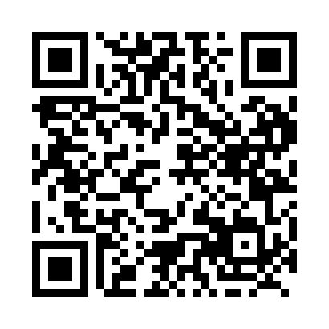
Prayer times for Baribeau, Quebec, Canada
Wed 1 May 2024 - Fri 31 May 2024
High Latitude Method: Angle Based Rule
Prayer Calculation Method: Islamic Society of North America
Asar Calculation Method: Hanafi

Date | Day | Fajr | Sunrise | Dhuhr | Asr | Maghrib | Isha
1 | Wed | 3:53 | 5:34 | 12:48 | 5:51 | 8:03 | 9:44
2 | Thu | 3:51 | 5:32 | 12:48 | 5:52 | 8:04 | 9:46
3 | Fri | 3:49 | 5:31 | 12:48 | 5:52 | 8:06 | 9:48
4 | Sat | 3:46 | 5:29 | 12:48 | 5:53 | 8:07 | 9:50
5 | Sun | 3:44 | 5:27 | 12:48 | 5:54 | 8:08 | 9:52
6 | Mon | 3:42 | 5:26 | 12:47 | 5:55 | 8:10 | 9:54
7 | Tue | 3:40 | 5:25 | 12:47 | 5:56 | 8:11 | 9:56
8 | Wed | 3:38 | 5:23 | 12:47 | 5:56 | 8:12 | 9:58
9 | Thu | 3:36 | 5:22 | 12:47 | 5:57 | 8:14 | 10:00
10 | Fri | 3:33 | 5:20 | 12:47 | 5:58 | 8:15 | 10:02
11 | Sat | 3:31 | 5:19 | 12:47 | 5:59 | 8:16 | 10:04
12 | Sun | 3:29 | 5:18 | 12:47 | 6:00 | 8:18 | 10:06
13 | Mon | 3:27 | 5:16 | 12:47 | 6:00 | 8:19 | 10:08
14 | Tue | 3:25 | 5:15 | 12:47 | 6:01 | 8:20 | 10:10
15 | Wed | 3:23 | 5:14 | 12:47 | 6:02 | 8:21 | 10:12
16 | Thu | 3:21 | 5:13 | 12:47 | 6:03 | 8:23 | 10:14
17 | Fri | 3:19 | 5:11 | 12:47 | 6:03 | 8:24 | 10:16
18 | Sat | 3:17 | 5:10 | 12:47 | 6:04 | 8:25 | 10:18
19 | Sun | 3:16 | 5:09 | 12:47 | 6:05 | 8:26 | 10:20
20 | Mon | 3:14 | 5:08 | 12:47 | 6:05 | 8:27 | 10:22
21 | Tue | 3:12 | 5:07 | 12:48 | 6:06 | 8:29 | 10:24
22 | Wed | 3:10 | 5:06 | 12:48 | 6:07 | 8:30 | 10:26
23 | Thu | 3:08 | 5:05 | 12:48 | 6:07 | 8:31 | 10:28
24 | Fri | 3:07 | 5:04 | 12:48 | 6:08 | 8:32 | 10:30
25 | Sat | 3:05 | 5:03 | 12:48 | 6:09 | 8:33 | 10:32
26 | Sun | 3:03 | 5:03 | 12:48 | 6:09 | 8:34 | 10:34
27 | Mon | 3:02 | 5:02 | 12:48 | 6:10 | 8:35 | 10:35
28 | Tue | 3:00 | 5:01 | 12:48 | 6:11 | 8:36 | 10:37
29 | Wed | 2:59 | 5:00 | 12:48 | 6:11 | 8:37 | 10:39
30 | Thu | 2:57 | 4:59 | 12:49 | 6:12 | 8:38 | 10:41
31 | Fri | 2:56 | 4:59 | 12:49 | 6:12 | 8:39 | 10:42
Prayer times provided by https://www.salahtimes.com

