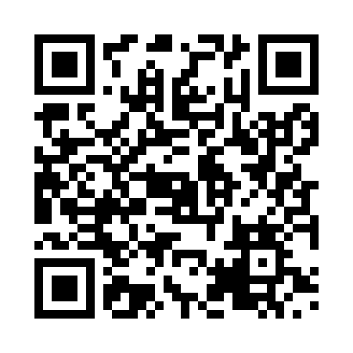

**Prayer times for Hercegovo, Kosovo**

**Sun 1 Dec 2024 - Tue 31 Dec 2024**

**High Latitude Method: None**

**Prayer Calculation Method: Muslim World League**

**Asar Calculation Method: Shafi**

|  |  |  |  |  |  |  |  |
| --- | --- | --- | --- | --- | --- | --- | --- |
| **Date** | **Day** | **Fajr** | **Sunrise** | **Dhuhr** | **Asr** | **Maghrib** | **Isha** |
| 1 | Sun | 5:07 | 6:48 | 11:26 | 1:45 | 4:03 | 5:39 |
| 2 | Mon | 5:08 | 6:49 | 11:26 | 1:45 | 4:03 | 5:39 |
| 3 | Tue | 5:09 | 6:50 | 11:26 | 1:45 | 4:03 | 5:39 |
| 4 | Wed | 5:09 | 6:51 | 11:27 | 1:44 | 4:03 | 5:38 |
| 5 | Thu | 5:10 | 6:52 | 11:27 | 1:44 | 4:03 | 5:38 |
| 6 | Fri | 5:11 | 6:53 | 11:28 | 1:44 | 4:02 | 5:38 |
| 7 | Sat | 5:12 | 6:54 | 11:28 | 1:44 | 4:02 | 5:38 |
| 8 | Sun | 5:13 | 6:55 | 11:29 | 1:44 | 4:02 | 5:39 |
| 9 | Mon | 5:14 | 6:56 | 11:29 | 1:44 | 4:02 | 5:39 |
| 10 | Tue | 5:14 | 6:56 | 11:30 | 1:45 | 4:02 | 5:39 |
| 11 | Wed | 5:15 | 6:57 | 11:30 | 1:45 | 4:02 | 5:39 |
| 12 | Thu | 5:16 | 6:58 | 11:30 | 1:45 | 4:03 | 5:39 |
| 13 | Fri | 5:17 | 6:59 | 11:31 | 1:45 | 4:03 | 5:39 |
| 14 | Sat | 5:17 | 7:00 | 11:31 | 1:45 | 4:03 | 5:40 |
| 15 | Sun | 5:18 | 7:00 | 11:32 | 1:46 | 4:03 | 5:40 |
| 16 | Mon | 5:19 | 7:01 | 11:32 | 1:46 | 4:04 | 5:40 |
| 17 | Tue | 5:19 | 7:02 | 11:33 | 1:46 | 4:04 | 5:41 |
| 18 | Wed | 5:20 | 7:02 | 11:33 | 1:47 | 4:04 | 5:41 |
| 19 | Thu | 5:20 | 7:03 | 11:34 | 1:47 | 4:05 | 5:41 |
| 20 | Fri | 5:21 | 7:04 | 11:34 | 1:48 | 4:05 | 5:42 |
| 21 | Sat | 5:21 | 7:04 | 11:35 | 1:48 | 4:06 | 5:42 |
| 22 | Sun | 5:22 | 7:05 | 11:35 | 1:49 | 4:06 | 5:43 |
| 23 | Mon | 5:22 | 7:05 | 11:36 | 1:49 | 4:07 | 5:44 |
| 24 | Tue | 5:23 | 7:05 | 11:36 | 1:50 | 4:07 | 5:44 |
| 25 | Wed | 5:23 | 7:06 | 11:37 | 1:50 | 4:08 | 5:45 |
| 26 | Thu | 5:24 | 7:06 | 11:37 | 1:51 | 4:09 | 5:45 |
| 27 | Fri | 5:24 | 7:06 | 11:38 | 1:52 | 4:09 | 5:46 |
| 28 | Sat | 5:24 | 7:07 | 11:38 | 1:52 | 4:10 | 5:47 |
| 29 | Sun | 5:25 | 7:07 | 11:39 | 1:53 | 4:11 | 5:47 |
| 30 | Mon | 5:25 | 7:07 | 11:39 | 1:54 | 4:12 | 5:48 |
| 31 | Tue | 5:25 | 7:07 | 11:40 | 1:55 | 4:12 | 5:49 |

**Prayer times provided by https://www.salahtimes.com**