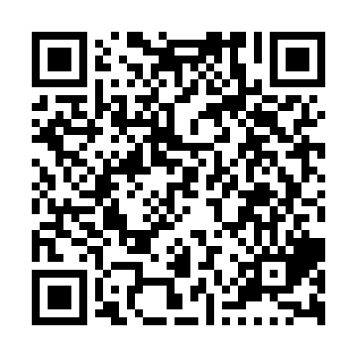
Prayer times for Upper Gulf Shore, Nova Scotia, Canada
Wed 1 May 2024 - Fri 31 May 2024
High Latitude Method: Angle Based Rule
Prayer Calculation Method: Islamic Society of North America
Asar Calculation Method: Hanafi

Date | Day | Fajr | Sunrise | Dhuhr | Asr | Maghrib | Isha
1 | Wed | 4:24 | 6:01 | 1:11 | 6:13 | 8:23 | 10:00
2 | Thu | 4:22 | 5:59 | 1:11 | 6:14 | 8:24 | 10:02
3 | Fri | 4:20 | 5:58 | 1:11 | 6:14 | 8:25 | 10:04
4 | Sat | 4:18 | 5:56 | 1:11 | 6:15 | 8:27 | 10:05
5 | Sun | 4:16 | 5:55 | 1:11 | 6:16 | 8:28 | 10:07
6 | Mon | 4:14 | 5:54 | 1:11 | 6:17 | 8:29 | 10:09
7 | Tue | 4:12 | 5:52 | 1:11 | 6:17 | 8:30 | 10:11
8 | Wed | 4:10 | 5:51 | 1:11 | 6:18 | 8:32 | 10:13
9 | Thu | 4:08 | 5:49 | 1:11 | 6:19 | 8:33 | 10:15
10 | Fri | 4:06 | 5:48 | 1:11 | 6:20 | 8:34 | 10:17
11 | Sat | 4:04 | 5:47 | 1:11 | 6:20 | 8:35 | 10:18
12 | Sun | 4:02 | 5:46 | 1:11 | 6:21 | 8:37 | 10:20
13 | Mon | 4:01 | 5:44 | 1:11 | 6:22 | 8:38 | 10:22
14 | Tue | 3:59 | 5:43 | 1:11 | 6:22 | 8:39 | 10:24
15 | Wed | 3:57 | 5:42 | 1:11 | 6:23 | 8:40 | 10:26
16 | Thu | 3:55 | 5:41 | 1:11 | 6:24 | 8:41 | 10:28
17 | Fri | 3:53 | 5:40 | 1:11 | 6:25 | 8:43 | 10:29
18 | Sat | 3:52 | 5:39 | 1:11 | 6:25 | 8:44 | 10:31
19 | Sun | 3:50 | 5:38 | 1:11 | 6:26 | 8:45 | 10:33
20 | Mon | 3:48 | 5:37 | 1:11 | 6:27 | 8:46 | 10:35
21 | Tue | 3:47 | 5:36 | 1:11 | 6:27 | 8:47 | 10:36
22 | Wed | 3:45 | 5:35 | 1:11 | 6:28 | 8:48 | 10:38
23 | Thu | 3:44 | 5:34 | 1:11 | 6:28 | 8:49 | 10:40
24 | Fri | 3:42 | 5:33 | 1:11 | 6:29 | 8:50 | 10:42
25 | Sat | 3:41 | 5:32 | 1:11 | 6:30 | 8:51 | 10:43
26 | Sun | 3:39 | 5:31 | 1:12 | 6:30 | 8:52 | 10:45
27 | Mon | 3:38 | 5:31 | 1:12 | 6:31 | 8:53 | 10:46
28 | Tue | 3:37 | 5:30 | 1:12 | 6:31 | 8:54 | 10:48
29 | Wed | 3:35 | 5:29 | 1:12 | 6:32 | 8:55 | 10:49
30 | Thu | 3:34 | 5:29 | 1:12 | 6:33 | 8:56 | 10:51
31 | Fri | 3:33 | 5:28 | 1:12 | 6:33 | 8:57 | 10:52
Prayer times provided by https://www.salahtimes.com

