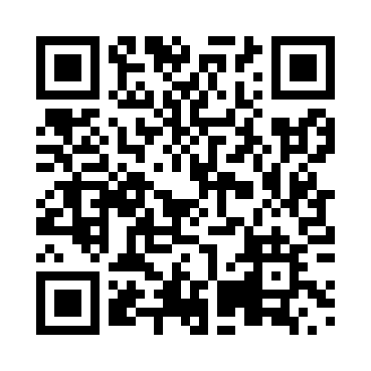
Prayer times for Upper Mills, New Brunswick, Canada
Wed 1 May 2024 - Fri 31 May 2024
High Latitude Method: Angle Based Rule
Prayer Calculation Method: Islamic Society of North America
Asar Calculation Method: Hanafi

Date | Day | Fajr | Sunrise | Dhuhr | Asr | Maghrib | Isha
1 | Wed | 4:43 | 6:17 | 1:26 | 6:27 | 8:36 | 10:11
2 | Thu | 4:41 | 6:16 | 1:26 | 6:28 | 8:37 | 10:13
3 | Fri | 4:39 | 6:15 | 1:26 | 6:28 | 8:38 | 10:14
4 | Sat | 4:37 | 6:13 | 1:26 | 6:29 | 8:40 | 10:16
5 | Sun | 4:35 | 6:12 | 1:26 | 6:30 | 8:41 | 10:18
6 | Mon | 4:33 | 6:10 | 1:26 | 6:31 | 8:42 | 10:20
7 | Tue | 4:31 | 6:09 | 1:26 | 6:31 | 8:43 | 10:22
8 | Wed | 4:29 | 6:08 | 1:26 | 6:32 | 8:44 | 10:23
9 | Thu | 4:27 | 6:06 | 1:26 | 6:33 | 8:46 | 10:25
10 | Fri | 4:25 | 6:05 | 1:26 | 6:33 | 8:47 | 10:27
11 | Sat | 4:24 | 6:04 | 1:26 | 6:34 | 8:48 | 10:29
12 | Sun | 4:22 | 6:03 | 1:26 | 6:35 | 8:49 | 10:30
13 | Mon | 4:20 | 6:01 | 1:26 | 6:35 | 8:50 | 10:32
14 | Tue | 4:18 | 6:00 | 1:26 | 6:36 | 8:52 | 10:34
15 | Wed | 4:17 | 5:59 | 1:26 | 6:37 | 8:53 | 10:36
16 | Thu | 4:15 | 5:58 | 1:26 | 6:38 | 8:54 | 10:37
17 | Fri | 4:13 | 5:57 | 1:26 | 6:38 | 8:55 | 10:39
18 | Sat | 4:12 | 5:56 | 1:26 | 6:39 | 8:56 | 10:41
19 | Sun | 4:10 | 5:55 | 1:26 | 6:39 | 8:57 | 10:43
20 | Mon | 4:08 | 5:54 | 1:26 | 6:40 | 8:58 | 10:44
21 | Tue | 4:07 | 5:53 | 1:26 | 6:41 | 8:59 | 10:46
22 | Wed | 4:05 | 5:52 | 1:26 | 6:41 | 9:00 | 10:48
23 | Thu | 4:04 | 5:51 | 1:26 | 6:42 | 9:01 | 10:49
24 | Fri | 4:03 | 5:50 | 1:26 | 6:43 | 9:02 | 10:51
25 | Sat | 4:01 | 5:50 | 1:26 | 6:43 | 9:03 | 10:52
26 | Sun | 4:00 | 5:49 | 1:26 | 6:44 | 9:04 | 10:54
27 | Mon | 3:59 | 5:48 | 1:27 | 6:44 | 9:05 | 10:55
28 | Tue | 3:57 | 5:47 | 1:27 | 6:45 | 9:06 | 10:57
29 | Wed | 3:56 | 5:47 | 1:27 | 6:46 | 9:07 | 10:58
30 | Thu | 3:55 | 5:46 | 1:27 | 6:46 | 9:08 | 11:00
31 | Fri | 3:54 | 5:46 | 1:27 | 6:47 | 9:09 | 11:01
Prayer times provided by https://www.salahtimes.com

