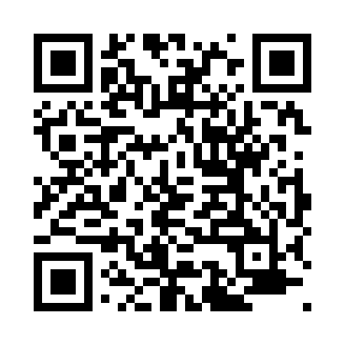

**Prayer times for Arnager, Denmark**

**Sun 1 Sep 2024 - Mon 30 Sep 2024**

**High Latitude Method: Angle Based Rule**

**Prayer Calculation Method: Muslim World League**

**Asar Calculation Method: Hanafi**

|  |  |  |  |  |  |  |  |
| --- | --- | --- | --- | --- | --- | --- | --- |
| **Date** | **Day** | **Fajr** | **Sunrise** | **Dhuhr** | **Asr** | **Maghrib** | **Isha** |
| 1 | Sun | 3:47 | 6:08 | 1:01 | 5:40 | 7:53 | 10:03 |
| 2 | Mon | 3:50 | 6:10 | 1:00 | 5:38 | 7:50 | 10:00 |
| 3 | Tue | 3:53 | 6:12 | 1:00 | 5:36 | 7:48 | 9:56 |
| 4 | Wed | 3:56 | 6:13 | 1:00 | 5:34 | 7:45 | 9:53 |
| 5 | Thu | 3:59 | 6:15 | 12:59 | 5:32 | 7:42 | 9:49 |
| 6 | Fri | 4:01 | 6:17 | 12:59 | 5:30 | 7:40 | 9:46 |
| 7 | Sat | 4:04 | 6:19 | 12:59 | 5:28 | 7:37 | 9:43 |
| 8 | Sun | 4:07 | 6:21 | 12:58 | 5:26 | 7:35 | 9:39 |
| 9 | Mon | 4:10 | 6:23 | 12:58 | 5:24 | 7:32 | 9:36 |
| 10 | Tue | 4:12 | 6:25 | 12:58 | 5:22 | 7:30 | 9:33 |
| 11 | Wed | 4:15 | 6:26 | 12:57 | 5:20 | 7:27 | 9:29 |
| 12 | Thu | 4:18 | 6:28 | 12:57 | 5:18 | 7:25 | 9:26 |
| 13 | Fri | 4:20 | 6:30 | 12:57 | 5:16 | 7:22 | 9:23 |
| 14 | Sat | 4:23 | 6:32 | 12:56 | 5:14 | 7:19 | 9:20 |
| 15 | Sun | 4:25 | 6:34 | 12:56 | 5:12 | 7:17 | 9:17 |
| 16 | Mon | 4:28 | 6:36 | 12:56 | 5:10 | 7:14 | 9:14 |
| 17 | Tue | 4:30 | 6:38 | 12:55 | 5:07 | 7:12 | 9:11 |
| 18 | Wed | 4:33 | 6:40 | 12:55 | 5:05 | 7:09 | 9:08 |
| 19 | Thu | 4:35 | 6:41 | 12:54 | 5:03 | 7:07 | 9:05 |
| 20 | Fri | 4:37 | 6:43 | 12:54 | 5:01 | 7:04 | 9:02 |
| 21 | Sat | 4:40 | 6:45 | 12:54 | 4:59 | 7:01 | 8:59 |
| 22 | Sun | 4:42 | 6:47 | 12:53 | 4:57 | 6:59 | 8:56 |
| 23 | Mon | 4:44 | 6:49 | 12:53 | 4:54 | 6:56 | 8:53 |
| 24 | Tue | 4:47 | 6:51 | 12:53 | 4:52 | 6:54 | 8:50 |
| 25 | Wed | 4:49 | 6:53 | 12:52 | 4:50 | 6:51 | 8:47 |
| 26 | Thu | 4:51 | 6:55 | 12:52 | 4:48 | 6:48 | 8:44 |
| 27 | Fri | 4:53 | 6:56 | 12:52 | 4:45 | 6:46 | 8:41 |
| 28 | Sat | 4:55 | 6:58 | 12:51 | 4:43 | 6:43 | 8:38 |
| 29 | Sun | 4:58 | 7:00 | 12:51 | 4:41 | 6:41 | 8:36 |
| 30 | Mon | 5:00 | 7:02 | 12:51 | 4:39 | 6:38 | 8:33 |

**Prayer times provided by https://www.salahtimes.com**