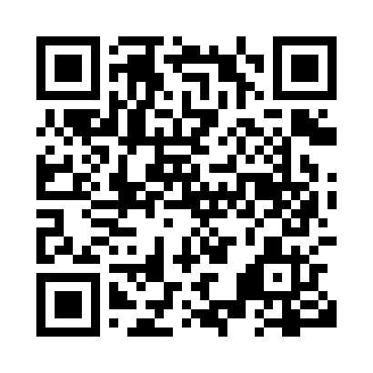

**Prayer times for Kemp River, Alberta, Canada**

**Wed 1 Jan 2025 - Fri 31 Jan 2025**

**High Latitude Method: Angle Based Rule**

**Prayer Calculation Method: Islamic Society of North America**

**Asar Calculation Method: Hanafi**

|  |  |  |  |  |  |  |  |
| --- | --- | --- | --- | --- | --- | --- | --- |
| **Date** | **Day** | **Fajr** | **Sunrise** | **Dhuhr** | **Asr** | **Maghrib** | **Isha** |
| 1 | Wed | 7:26 | 9:32 | 12:54 | 2:28 | 4:16 | 6:22 |
| 2 | Thu | 7:26 | 9:31 | 12:54 | 2:29 | 4:18 | 6:23 |
| 3 | Fri | 7:26 | 9:31 | 12:55 | 2:30 | 4:19 | 6:24 |
| 4 | Sat | 7:26 | 9:30 | 12:55 | 2:32 | 4:21 | 6:25 |
| 5 | Sun | 7:25 | 9:30 | 12:56 | 2:33 | 4:22 | 6:26 |
| 6 | Mon | 7:25 | 9:29 | 12:56 | 2:34 | 4:24 | 6:27 |
| 7 | Tue | 7:25 | 9:28 | 12:56 | 2:36 | 4:25 | 6:29 |
| 8 | Wed | 7:24 | 9:27 | 12:57 | 2:37 | 4:27 | 6:30 |
| 9 | Thu | 7:24 | 9:27 | 12:57 | 2:39 | 4:29 | 6:31 |
| 10 | Fri | 7:23 | 9:26 | 12:58 | 2:41 | 4:31 | 6:33 |
| 11 | Sat | 7:23 | 9:25 | 12:58 | 2:42 | 4:32 | 6:34 |
| 12 | Sun | 7:22 | 9:23 | 12:59 | 2:44 | 4:34 | 6:36 |
| 13 | Mon | 7:21 | 9:22 | 12:59 | 2:46 | 4:36 | 6:37 |
| 14 | Tue | 7:20 | 9:21 | 12:59 | 2:47 | 4:38 | 6:39 |
| 15 | Wed | 7:20 | 9:20 | 1:00 | 2:49 | 4:40 | 6:40 |
| 16 | Thu | 7:19 | 9:18 | 1:00 | 2:51 | 4:42 | 6:42 |
| 17 | Fri | 7:18 | 9:17 | 1:00 | 2:53 | 4:44 | 6:43 |
| 18 | Sat | 7:17 | 9:16 | 1:01 | 2:55 | 4:46 | 6:45 |
| 19 | Sun | 7:16 | 9:14 | 1:01 | 2:57 | 4:48 | 6:47 |
| 20 | Mon | 7:15 | 9:13 | 1:01 | 2:59 | 4:51 | 6:48 |
| 21 | Tue | 7:13 | 9:11 | 1:01 | 3:01 | 4:53 | 6:50 |
| 22 | Wed | 7:12 | 9:09 | 1:02 | 3:03 | 4:55 | 6:52 |
| 23 | Thu | 7:11 | 9:08 | 1:02 | 3:05 | 4:57 | 6:54 |
| 24 | Fri | 7:10 | 9:06 | 1:02 | 3:07 | 4:59 | 6:55 |
| 25 | Sat | 7:08 | 9:04 | 1:02 | 3:09 | 5:02 | 6:57 |
| 26 | Sun | 7:07 | 9:02 | 1:03 | 3:11 | 5:04 | 6:59 |
| 27 | Mon | 7:06 | 9:00 | 1:03 | 3:13 | 5:06 | 7:01 |
| 28 | Tue | 7:04 | 8:59 | 1:03 | 3:15 | 5:08 | 7:03 |
| 29 | Wed | 7:03 | 8:57 | 1:03 | 3:17 | 5:11 | 7:05 |
| 30 | Thu | 7:01 | 8:55 | 1:03 | 3:19 | 5:13 | 7:07 |
| 31 | Fri | 6:59 | 8:53 | 1:03 | 3:21 | 5:15 | 7:09 |

**Prayer times provided by https://www.salahtimes.com**