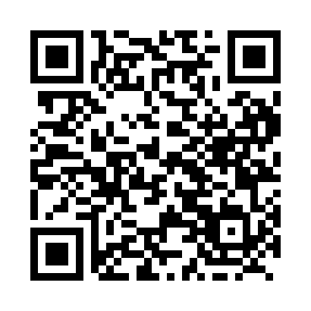

**Prayer times for Barrett Lake, British Columbia, Canada**

**Thu 1 Aug 2024 - Sat 31 Aug 2024**

**High Latitude Method: Angle Based Rule**

**Prayer Calculation Method: Islamic Society of North America**

**Asar Calculation Method: Hanafi**

|  |  |  |  |  |  |  |  |
| --- | --- | --- | --- | --- | --- | --- | --- |
| **Date** | **Day** | **Fajr** | **Sunrise** | **Dhuhr** | **Asr** | **Maghrib** | **Isha** |
| 1 | Thu | 3:36 | 5:40 | 1:33 | 6:54 | 9:26 | 11:29 |
| 2 | Fri | 3:37 | 5:42 | 1:33 | 6:53 | 9:24 | 11:28 |
| 3 | Sat | 3:38 | 5:43 | 1:33 | 6:52 | 9:22 | 11:27 |
| 4 | Sun | 3:39 | 5:45 | 1:33 | 6:50 | 9:20 | 11:26 |
| 5 | Mon | 3:40 | 5:47 | 1:33 | 6:49 | 9:18 | 11:25 |
| 6 | Tue | 3:40 | 5:49 | 1:33 | 6:48 | 9:16 | 11:24 |
| 7 | Wed | 3:41 | 5:50 | 1:33 | 6:46 | 9:14 | 11:23 |
| 8 | Thu | 3:42 | 5:52 | 1:33 | 6:45 | 9:12 | 11:22 |
| 9 | Fri | 3:43 | 5:54 | 1:32 | 6:44 | 9:10 | 11:21 |
| 10 | Sat | 3:44 | 5:56 | 1:32 | 6:42 | 9:08 | 11:20 |
| 11 | Sun | 3:45 | 5:58 | 1:32 | 6:41 | 9:06 | 11:17 |
| 12 | Mon | 3:49 | 5:59 | 1:32 | 6:39 | 9:03 | 11:13 |
| 13 | Tue | 3:52 | 6:01 | 1:32 | 6:38 | 9:01 | 11:10 |
| 14 | Wed | 3:55 | 6:03 | 1:32 | 6:37 | 8:59 | 11:06 |
| 15 | Thu | 3:58 | 6:05 | 1:31 | 6:35 | 8:57 | 11:03 |
| 16 | Fri | 4:01 | 6:07 | 1:31 | 6:33 | 8:55 | 10:59 |
| 17 | Sat | 4:04 | 6:08 | 1:31 | 6:32 | 8:52 | 10:56 |
| 18 | Sun | 4:08 | 6:10 | 1:31 | 6:30 | 8:50 | 10:52 |
| 19 | Mon | 4:11 | 6:12 | 1:30 | 6:29 | 8:48 | 10:49 |
| 20 | Tue | 4:13 | 6:14 | 1:30 | 6:27 | 8:45 | 10:45 |
| 21 | Wed | 4:16 | 6:16 | 1:30 | 6:25 | 8:43 | 10:42 |
| 22 | Thu | 4:19 | 6:18 | 1:30 | 6:24 | 8:41 | 10:38 |
| 23 | Fri | 4:22 | 6:19 | 1:29 | 6:22 | 8:38 | 10:35 |
| 24 | Sat | 4:25 | 6:21 | 1:29 | 6:20 | 8:36 | 10:32 |
| 25 | Sun | 4:28 | 6:23 | 1:29 | 6:18 | 8:34 | 10:28 |
| 26 | Mon | 4:30 | 6:25 | 1:29 | 6:17 | 8:31 | 10:25 |
| 27 | Tue | 4:33 | 6:27 | 1:28 | 6:15 | 8:29 | 10:22 |
| 28 | Wed | 4:36 | 6:29 | 1:28 | 6:13 | 8:26 | 10:19 |
| 29 | Thu | 4:38 | 6:30 | 1:28 | 6:11 | 8:24 | 10:15 |
| 30 | Fri | 4:41 | 6:32 | 1:27 | 6:09 | 8:22 | 10:12 |
| 31 | Sat | 4:44 | 6:34 | 1:27 | 6:07 | 8:19 | 10:09 |

**Prayer times provided by https://www.salahtimes.com**