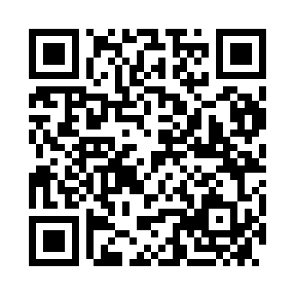
Prayer times for Schrems, Austria
Mon 1 Apr 2024 - Tue 30 Apr 2024
High Latitude Method: Angle Based Rule
Prayer Calculation Method: Muslim World League
Asar Calculation Method: Shafi

Date | Day | Fajr | Sunrise | Dhuhr | Asr | Maghrib | Isha
1 | Mon | 4:46 | 6:37 | 1:04 | 4:38 | 7:31 | 9:15
2 | Tue | 4:44 | 6:35 | 1:03 | 4:38 | 7:33 | 9:17
3 | Wed | 4:41 | 6:33 | 1:03 | 4:39 | 7:34 | 9:19
4 | Thu | 4:38 | 6:31 | 1:03 | 4:40 | 7:36 | 9:21
5 | Fri | 4:36 | 6:29 | 1:02 | 4:41 | 7:37 | 9:23
6 | Sat | 4:33 | 6:26 | 1:02 | 4:41 | 7:39 | 9:25
7 | Sun | 4:31 | 6:24 | 1:02 | 4:42 | 7:40 | 9:27
8 | Mon | 4:28 | 6:22 | 1:02 | 4:43 | 7:42 | 9:29
9 | Tue | 4:26 | 6:20 | 1:01 | 4:43 | 7:43 | 9:31
10 | Wed | 4:23 | 6:18 | 1:01 | 4:44 | 7:45 | 9:33
11 | Thu | 4:20 | 6:16 | 1:01 | 4:45 | 7:46 | 9:35
12 | Fri | 4:18 | 6:14 | 1:00 | 4:45 | 7:48 | 9:37
13 | Sat | 4:15 | 6:12 | 1:00 | 4:46 | 7:49 | 9:39
14 | Sun | 4:12 | 6:10 | 1:00 | 4:47 | 7:50 | 9:41
15 | Mon | 4:10 | 6:08 | 1:00 | 4:47 | 7:52 | 9:43
16 | Tue | 4:07 | 6:06 | 1:00 | 4:48 | 7:53 | 9:45
17 | Wed | 4:04 | 6:04 | 12:59 | 4:49 | 7:55 | 9:47
18 | Thu | 4:02 | 6:03 | 12:59 | 4:49 | 7:56 | 9:50
19 | Fri | 3:59 | 6:01 | 12:59 | 4:50 | 7:58 | 9:52
20 | Sat | 3:56 | 5:59 | 12:59 | 4:51 | 7:59 | 9:54
21 | Sun | 3:53 | 5:57 | 12:58 | 4:51 | 8:01 | 9:56
22 | Mon | 3:51 | 5:55 | 12:58 | 4:52 | 8:02 | 9:59
23 | Tue | 3:48 | 5:53 | 12:58 | 4:52 | 8:04 | 10:01
24 | Wed | 3:45 | 5:51 | 12:58 | 4:53 | 8:05 | 10:03
25 | Thu | 3:42 | 5:49 | 12:58 | 4:54 | 8:07 | 10:05
26 | Fri | 3:40 | 5:48 | 12:58 | 4:54 | 8:08 | 10:08
27 | Sat | 3:37 | 5:46 | 12:57 | 4:55 | 8:10 | 10:10
28 | Sun | 3:34 | 5:44 | 12:57 | 4:55 | 8:11 | 10:12
29 | Mon | 3:31 | 5:42 | 12:57 | 4:56 | 8:13 | 10:15
30 | Tue | 3:29 | 5:41 | 12:57 | 4:57 | 8:14 | 10:17
Prayer times provided by https://www.salahtimes.com

