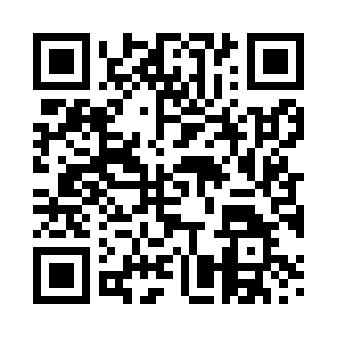

**Prayer times for Brondum, Denmark**

**Sun 1 Sep 2024 - Mon 30 Sep 2024**

**High Latitude Method: Angle Based Rule**

**Prayer Calculation Method: Muslim World League**

**Asar Calculation Method: Hanafi**

|  |  |  |  |  |  |  |  |
| --- | --- | --- | --- | --- | --- | --- | --- |
| **Date** | **Day** | **Fajr** | **Sunrise** | **Dhuhr** | **Asr** | **Maghrib** | **Isha** |
| 1 | Sun | 3:52 | 6:26 | 1:23 | 6:02 | 8:19 | 10:40 |
| 2 | Mon | 3:56 | 6:28 | 1:22 | 6:00 | 8:16 | 10:36 |
| 3 | Tue | 3:59 | 6:30 | 1:22 | 5:58 | 8:13 | 10:32 |
| 4 | Wed | 4:03 | 6:32 | 1:22 | 5:56 | 8:11 | 10:28 |
| 5 | Thu | 4:06 | 6:34 | 1:21 | 5:54 | 8:08 | 10:24 |
| 6 | Fri | 4:10 | 6:36 | 1:21 | 5:52 | 8:05 | 10:20 |
| 7 | Sat | 4:13 | 6:38 | 1:21 | 5:49 | 8:02 | 10:17 |
| 8 | Sun | 4:16 | 6:40 | 1:20 | 5:47 | 8:00 | 10:13 |
| 9 | Mon | 4:19 | 6:42 | 1:20 | 5:45 | 7:57 | 10:09 |
| 10 | Tue | 4:22 | 6:44 | 1:20 | 5:43 | 7:54 | 10:06 |
| 11 | Wed | 4:25 | 6:46 | 1:19 | 5:41 | 7:51 | 10:02 |
| 12 | Thu | 4:28 | 6:48 | 1:19 | 5:38 | 7:49 | 9:59 |
| 13 | Fri | 4:31 | 6:50 | 1:19 | 5:36 | 7:46 | 9:55 |
| 14 | Sat | 4:34 | 6:52 | 1:18 | 5:34 | 7:43 | 9:52 |
| 15 | Sun | 4:37 | 6:54 | 1:18 | 5:32 | 7:40 | 9:48 |
| 16 | Mon | 4:40 | 6:56 | 1:18 | 5:29 | 7:38 | 9:45 |
| 17 | Tue | 4:43 | 6:58 | 1:17 | 5:27 | 7:35 | 9:41 |
| 18 | Wed | 4:45 | 7:00 | 1:17 | 5:25 | 7:32 | 9:38 |
| 19 | Thu | 4:48 | 7:03 | 1:17 | 5:23 | 7:29 | 9:35 |
| 20 | Fri | 4:51 | 7:05 | 1:16 | 5:20 | 7:27 | 9:32 |
| 21 | Sat | 4:53 | 7:07 | 1:16 | 5:18 | 7:24 | 9:28 |
| 22 | Sun | 4:56 | 7:09 | 1:15 | 5:16 | 7:21 | 9:25 |
| 23 | Mon | 4:58 | 7:11 | 1:15 | 5:13 | 7:18 | 9:22 |
| 24 | Tue | 5:01 | 7:13 | 1:15 | 5:11 | 7:16 | 9:19 |
| 25 | Wed | 5:03 | 7:15 | 1:14 | 5:09 | 7:13 | 9:16 |
| 26 | Thu | 5:06 | 7:17 | 1:14 | 5:06 | 7:10 | 9:13 |
| 27 | Fri | 5:08 | 7:19 | 1:14 | 5:04 | 7:07 | 9:09 |
| 28 | Sat | 5:11 | 7:21 | 1:13 | 5:01 | 7:05 | 9:06 |
| 29 | Sun | 5:13 | 7:23 | 1:13 | 4:59 | 7:02 | 9:03 |
| 30 | Mon | 5:16 | 7:25 | 1:13 | 4:57 | 6:59 | 9:00 |

**Prayer times provided by https://www.salahtimes.com**