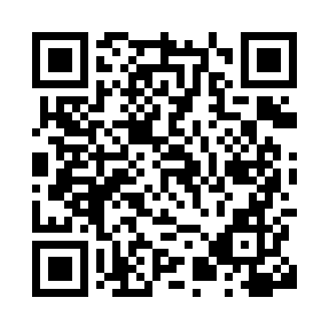
Prayer times for Lombez, France
Wed 1 May 2024 - Fri 31 May 2024
High Latitude Method: Angle Based Rule
Prayer Calculation Method: Islamic Organisations Union of France
Asar Calculation Method: Shafi

Date | Day | Fajr | Sunrise | Dhuhr | Asr | Maghrib | Isha
1 | Wed | 5:39 | 6:49 | 1:53 | 5:48 | 8:59 | 10:09
2 | Thu | 5:37 | 6:47 | 1:53 | 5:48 | 9:00 | 10:11
3 | Fri | 5:35 | 6:46 | 1:53 | 5:49 | 9:01 | 10:12
4 | Sat | 5:34 | 6:45 | 1:53 | 5:49 | 9:02 | 10:13
5 | Sun | 5:32 | 6:43 | 1:53 | 5:50 | 9:03 | 10:15
6 | Mon | 5:30 | 6:42 | 1:53 | 5:50 | 9:05 | 10:16
7 | Tue | 5:29 | 6:41 | 1:53 | 5:50 | 9:06 | 10:18
8 | Wed | 5:27 | 6:39 | 1:53 | 5:51 | 9:07 | 10:19
9 | Thu | 5:26 | 6:38 | 1:53 | 5:51 | 9:08 | 10:21
10 | Fri | 5:24 | 6:37 | 1:53 | 5:51 | 9:09 | 10:22
11 | Sat | 5:23 | 6:36 | 1:53 | 5:52 | 9:10 | 10:24
12 | Sun | 5:21 | 6:35 | 1:53 | 5:52 | 9:11 | 10:25
13 | Mon | 5:20 | 6:34 | 1:53 | 5:52 | 9:12 | 10:27
14 | Tue | 5:18 | 6:32 | 1:53 | 5:53 | 9:14 | 10:28
15 | Wed | 5:17 | 6:31 | 1:53 | 5:53 | 9:15 | 10:29
16 | Thu | 5:15 | 6:30 | 1:53 | 5:53 | 9:16 | 10:31
17 | Fri | 5:14 | 6:29 | 1:53 | 5:54 | 9:17 | 10:32
18 | Sat | 5:13 | 6:28 | 1:53 | 5:54 | 9:18 | 10:34
19 | Sun | 5:12 | 6:27 | 1:53 | 5:54 | 9:19 | 10:35
20 | Mon | 5:10 | 6:27 | 1:53 | 5:55 | 9:20 | 10:36
21 | Tue | 5:09 | 6:26 | 1:53 | 5:55 | 9:21 | 10:38
22 | Wed | 5:08 | 6:25 | 1:53 | 5:56 | 9:22 | 10:39
23 | Thu | 5:07 | 6:24 | 1:53 | 5:56 | 9:23 | 10:40
24 | Fri | 5:06 | 6:23 | 1:53 | 5:56 | 9:24 | 10:42
25 | Sat | 5:05 | 6:22 | 1:53 | 5:57 | 9:25 | 10:43
26 | Sun | 5:04 | 6:22 | 1:53 | 5:57 | 9:26 | 10:44
27 | Mon | 5:03 | 6:21 | 1:54 | 5:57 | 9:27 | 10:45
28 | Tue | 5:02 | 6:20 | 1:54 | 5:58 | 9:27 | 10:46
29 | Wed | 5:01 | 6:20 | 1:54 | 5:58 | 9:28 | 10:48
30 | Thu | 5:00 | 6:19 | 1:54 | 5:58 | 9:29 | 10:49
31 | Fri | 4:59 | 6:19 | 1:54 | 5:59 | 9:30 | 10:50
Prayer times provided by https://www.salahtimes.com

