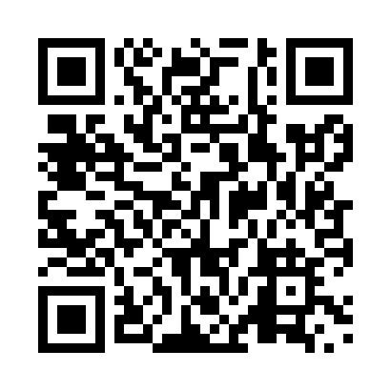
Prayer times for Whati, Northwest Territories, Canada
Wed 1 May 2024 - Fri 31 May 2024
High Latitude Method: Angle Based Rule
Prayer Calculation Method: Islamic Society of North America
Asar Calculation Method: Hanafi

Date | Day | Fajr | Sunrise | Dhuhr | Asr | Maghrib | Isha
1 | Wed | 3:36 | 5:26 | 1:46 | 7:09 | 10:08 | 11:57
2 | Thu | 3:35 | 5:23 | 1:46 | 7:11 | 10:11 | 11:59
3 | Fri | 3:33 | 5:19 | 1:46 | 7:13 | 10:14 | 12:00
4 | Sat | 3:31 | 5:16 | 1:46 | 7:14 | 10:17 | 12:02
5 | Sun | 3:30 | 5:13 | 1:46 | 7:16 | 10:20 | 12:03
6 | Mon | 3:28 | 5:10 | 1:46 | 7:17 | 10:23 | 12:05
7 | Tue | 3:27 | 5:07 | 1:46 | 7:19 | 10:26 | 12:06
8 | Wed | 3:25 | 5:04 | 1:46 | 7:21 | 10:29 | 12:08
9 | Thu | 3:23 | 5:00 | 1:46 | 7:22 | 10:32 | 12:09
10 | Fri | 3:22 | 4:57 | 1:45 | 7:24 | 10:35 | 12:11
11 | Sat | 3:20 | 4:54 | 1:45 | 7:25 | 10:38 | 12:12
12 | Sun | 3:19 | 4:51 | 1:45 | 7:27 | 10:41 | 12:14
13 | Mon | 3:17 | 4:48 | 1:45 | 7:28 | 10:44 | 12:15
14 | Tue | 3:16 | 4:45 | 1:45 | 7:30 | 10:47 | 12:17
15 | Wed | 3:14 | 4:42 | 1:45 | 7:31 | 10:50 | 12:18
16 | Thu | 3:13 | 4:39 | 1:46 | 7:32 | 10:53 | 12:20
17 | Fri | 3:11 | 4:37 | 1:46 | 7:34 | 10:56 | 12:21
18 | Sat | 3:10 | 4:34 | 1:46 | 7:35 | 10:59 | 12:23
19 | Sun | 3:09 | 4:31 | 1:46 | 7:36 | 11:02 | 12:24
20 | Mon | 3:07 | 4:28 | 1:46 | 7:38 | 11:05 | 12:26
21 | Tue | 3:06 | 4:25 | 1:46 | 7:39 | 11:08 | 12:27
22 | Wed | 3:05 | 4:23 | 1:46 | 7:40 | 11:10 | 12:28
23 | Thu | 3:03 | 4:20 | 1:46 | 7:42 | 11:13 | 12:30
24 | Fri | 3:02 | 4:17 | 1:46 | 7:43 | 11:16 | 12:31
25 | Sat | 3:01 | 4:15 | 1:46 | 7:44 | 11:19 | 12:33
26 | Sun | 3:00 | 4:12 | 1:46 | 7:45 | 11:21 | 12:34
27 | Mon | 2:58 | 4:10 | 1:46 | 7:46 | 11:24 | 12:36
28 | Tue | 2:57 | 4:08 | 1:47 | 7:47 | 11:27 | 12:37
29 | Wed | 2:56 | 4:05 | 1:47 | 7:48 | 11:29 | 12:38
30 | Thu | 2:55 | 4:03 | 1:47 | 7:49 | 11:32 | 12:40
31 | Fri | 2:54 | 4:01 | 1:47 | 7:50 | 11:34 | 12:41
Prayer times provided by https://www.salahtimes.com

