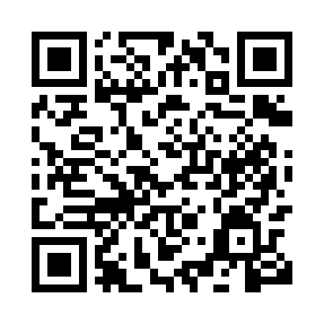
Prayer times for Uiwang, South Korea
Wed 1 May 2024 - Fri 31 May 2024
High Latitude Method: None
Prayer Calculation Method: Muslim World League
Asar Calculation Method: Shafi

Date | Day | Fajr | Sunrise | Dhuhr | Asr | Maghrib | Isha
1 | Wed | 3:59 | 5:37 | 12:29 | 4:16 | 7:22 | 8:54
2 | Thu | 3:58 | 5:36 | 12:29 | 4:17 | 7:23 | 8:55
3 | Fri | 3:56 | 5:35 | 12:29 | 4:17 | 7:24 | 8:56
4 | Sat | 3:55 | 5:34 | 12:29 | 4:17 | 7:24 | 8:57
5 | Sun | 3:53 | 5:33 | 12:29 | 4:17 | 7:25 | 8:59
6 | Mon | 3:52 | 5:32 | 12:29 | 4:17 | 7:26 | 9:00
7 | Tue | 3:50 | 5:31 | 12:29 | 4:17 | 7:27 | 9:01
8 | Wed | 3:49 | 5:30 | 12:29 | 4:18 | 7:28 | 9:03
9 | Thu | 3:48 | 5:29 | 12:29 | 4:18 | 7:29 | 9:04
10 | Fri | 3:46 | 5:28 | 12:29 | 4:18 | 7:30 | 9:05
11 | Sat | 3:45 | 5:27 | 12:29 | 4:18 | 7:31 | 9:06
12 | Sun | 3:44 | 5:26 | 12:29 | 4:18 | 7:32 | 9:08
13 | Mon | 3:42 | 5:25 | 12:28 | 4:18 | 7:32 | 9:09
14 | Tue | 3:41 | 5:24 | 12:28 | 4:19 | 7:33 | 9:10
15 | Wed | 3:40 | 5:23 | 12:29 | 4:19 | 7:34 | 9:11
16 | Thu | 3:38 | 5:23 | 12:29 | 4:19 | 7:35 | 9:12
17 | Fri | 3:37 | 5:22 | 12:29 | 4:19 | 7:36 | 9:14
18 | Sat | 3:36 | 5:21 | 12:29 | 4:19 | 7:37 | 9:15
19 | Sun | 3:35 | 5:20 | 12:29 | 4:20 | 7:37 | 9:16
20 | Mon | 3:34 | 5:19 | 12:29 | 4:20 | 7:38 | 9:17
21 | Tue | 3:33 | 5:19 | 12:29 | 4:20 | 7:39 | 9:18
22 | Wed | 3:32 | 5:18 | 12:29 | 4:20 | 7:40 | 9:20
23 | Thu | 3:31 | 5:18 | 12:29 | 4:20 | 7:41 | 9:21
24 | Fri | 3:30 | 5:17 | 12:29 | 4:21 | 7:41 | 9:22
25 | Sat | 3:29 | 5:16 | 12:29 | 4:21 | 7:42 | 9:23
26 | Sun | 3:28 | 5:16 | 12:29 | 4:21 | 7:43 | 9:24
27 | Mon | 3:27 | 5:15 | 12:29 | 4:21 | 7:44 | 9:25
28 | Tue | 3:26 | 5:15 | 12:29 | 4:21 | 7:44 | 9:26
29 | Wed | 3:25 | 5:14 | 12:30 | 4:22 | 7:45 | 9:27
30 | Thu | 3:24 | 5:14 | 12:30 | 4:22 | 7:46 | 9:28
31 | Fri | 3:24 | 5:14 | 12:30 | 4:22 | 7:46 | 9:29
Prayer times provided by https://www.salahtimes.com

