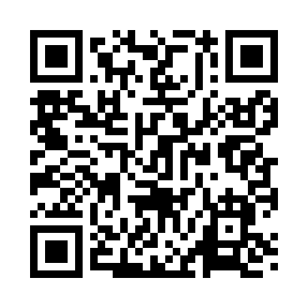
Prayer times for Jeffreys, Missouri, USA
Mon 1 Jul 2024 - Wed 31 Jul 2024
High Latitude Method: Angle Based Rule
Prayer Calculation Method: Islamic Society of North America
Asar Calculation Method: Shafi

Date | Day | Fajr | Sunrise | Dhuhr | Asr | Maghrib | Isha
1 | Mon | 4:23 | 5:57 | 1:22 | 5:18 | 8:47 | 10:21
2 | Tue | 4:23 | 5:57 | 1:22 | 5:18 | 8:47 | 10:21
3 | Wed | 4:24 | 5:58 | 1:23 | 5:19 | 8:47 | 10:21
4 | Thu | 4:25 | 5:58 | 1:23 | 5:19 | 8:47 | 10:20
5 | Fri | 4:26 | 5:59 | 1:23 | 5:19 | 8:47 | 10:20
6 | Sat | 4:26 | 5:59 | 1:23 | 5:19 | 8:46 | 10:19
7 | Sun | 4:27 | 6:00 | 1:23 | 5:19 | 8:46 | 10:19
8 | Mon | 4:28 | 6:01 | 1:23 | 5:19 | 8:46 | 10:18
9 | Tue | 4:29 | 6:01 | 1:24 | 5:19 | 8:45 | 10:18
10 | Wed | 4:30 | 6:02 | 1:24 | 5:19 | 8:45 | 10:17
11 | Thu | 4:31 | 6:03 | 1:24 | 5:19 | 8:45 | 10:16
12 | Fri | 4:32 | 6:03 | 1:24 | 5:19 | 8:44 | 10:16
13 | Sat | 4:33 | 6:04 | 1:24 | 5:19 | 8:44 | 10:15
14 | Sun | 4:34 | 6:05 | 1:24 | 5:19 | 8:43 | 10:14
15 | Mon | 4:35 | 6:06 | 1:24 | 5:19 | 8:43 | 10:13
16 | Tue | 4:36 | 6:06 | 1:24 | 5:19 | 8:42 | 10:12
17 | Wed | 4:37 | 6:07 | 1:24 | 5:19 | 8:41 | 10:11
18 | Thu | 4:38 | 6:08 | 1:24 | 5:19 | 8:41 | 10:10
19 | Fri | 4:39 | 6:09 | 1:25 | 5:19 | 8:40 | 10:09
20 | Sat | 4:40 | 6:09 | 1:25 | 5:19 | 8:39 | 10:08
21 | Sun | 4:41 | 6:10 | 1:25 | 5:19 | 8:39 | 10:07
22 | Mon | 4:42 | 6:11 | 1:25 | 5:19 | 8:38 | 10:06
23 | Tue | 4:44 | 6:12 | 1:25 | 5:18 | 8:37 | 10:05
24 | Wed | 4:45 | 6:13 | 1:25 | 5:18 | 8:36 | 10:04
25 | Thu | 4:46 | 6:14 | 1:25 | 5:18 | 8:35 | 10:03
26 | Fri | 4:47 | 6:14 | 1:25 | 5:18 | 8:35 | 10:02
27 | Sat | 4:48 | 6:15 | 1:25 | 5:18 | 8:34 | 10:00
28 | Sun | 4:49 | 6:16 | 1:25 | 5:17 | 8:33 | 9:59
29 | Mon | 4:51 | 6:17 | 1:25 | 5:17 | 8:32 | 9:58
30 | Tue | 4:52 | 6:18 | 1:25 | 5:17 | 8:31 | 9:57
31 | Wed | 4:53 | 6:19 | 1:24 | 5:17 | 8:30 | 9:55
Prayer times provided by https://www.salahtimes.com

