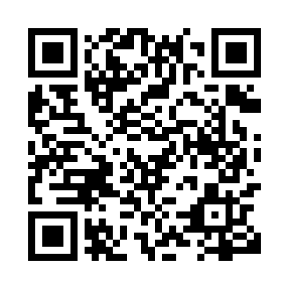

**Prayer times for Pukatawagan, Manitoba, Canada**

**Sun 1 Sep 2024 - Mon 30 Sep 2024**

**High Latitude Method: Angle Based Rule**

**Prayer Calculation Method: Islamic Society of North America**

**Asar Calculation Method: Hanafi**

|  |  |  |  |  |  |  |  |
| --- | --- | --- | --- | --- | --- | --- | --- |
| **Date** | **Day** | **Fajr** | **Sunrise** | **Dhuhr** | **Asr** | **Maghrib** | **Isha** |
| 1 | Sun | 4:57 | 6:51 | 1:45 | 6:24 | 8:37 | 10:32 |
| 2 | Mon | 4:59 | 6:53 | 1:45 | 6:22 | 8:35 | 10:28 |
| 3 | Tue | 5:02 | 6:55 | 1:44 | 6:20 | 8:32 | 10:25 |
| 4 | Wed | 5:05 | 6:57 | 1:44 | 6:18 | 8:30 | 10:22 |
| 5 | Thu | 5:07 | 6:59 | 1:44 | 6:16 | 8:27 | 10:18 |
| 6 | Fri | 5:10 | 7:01 | 1:43 | 6:14 | 8:24 | 10:15 |
| 7 | Sat | 5:13 | 7:03 | 1:43 | 6:12 | 8:22 | 10:12 |
| 8 | Sun | 5:15 | 7:05 | 1:43 | 6:10 | 8:19 | 10:09 |
| 9 | Mon | 5:18 | 7:07 | 1:42 | 6:08 | 8:17 | 10:05 |
| 10 | Tue | 5:20 | 7:09 | 1:42 | 6:05 | 8:14 | 10:02 |
| 11 | Wed | 5:23 | 7:11 | 1:42 | 6:03 | 8:11 | 9:59 |
| 12 | Thu | 5:25 | 7:13 | 1:41 | 6:01 | 8:09 | 9:56 |
| 13 | Fri | 5:27 | 7:15 | 1:41 | 5:59 | 8:06 | 9:53 |
| 14 | Sat | 5:30 | 7:16 | 1:41 | 5:57 | 8:03 | 9:50 |
| 15 | Sun | 5:32 | 7:18 | 1:40 | 5:55 | 8:01 | 9:47 |
| 16 | Mon | 5:35 | 7:20 | 1:40 | 5:52 | 7:58 | 9:44 |
| 17 | Tue | 5:37 | 7:22 | 1:39 | 5:50 | 7:56 | 9:41 |
| 18 | Wed | 5:39 | 7:24 | 1:39 | 5:48 | 7:53 | 9:38 |
| 19 | Thu | 5:41 | 7:26 | 1:39 | 5:46 | 7:50 | 9:35 |
| 20 | Fri | 5:44 | 7:28 | 1:38 | 5:44 | 7:48 | 9:32 |
| 21 | Sat | 5:46 | 7:30 | 1:38 | 5:41 | 7:45 | 9:29 |
| 22 | Sun | 5:48 | 7:32 | 1:38 | 5:39 | 7:42 | 9:26 |
| 23 | Mon | 5:50 | 7:34 | 1:37 | 5:37 | 7:40 | 9:23 |
| 24 | Tue | 5:53 | 7:36 | 1:37 | 5:35 | 7:37 | 9:20 |
| 25 | Wed | 5:55 | 7:38 | 1:37 | 5:32 | 7:34 | 9:17 |
| 26 | Thu | 5:57 | 7:40 | 1:36 | 5:30 | 7:32 | 9:14 |
| 27 | Fri | 5:59 | 7:42 | 1:36 | 5:28 | 7:29 | 9:12 |
| 28 | Sat | 6:01 | 7:44 | 1:36 | 5:26 | 7:27 | 9:09 |
| 29 | Sun | 6:03 | 7:45 | 1:35 | 5:23 | 7:24 | 9:06 |
| 30 | Mon | 6:05 | 7:47 | 1:35 | 5:21 | 7:21 | 9:03 |

**Prayer times provided by https://www.salahtimes.com**