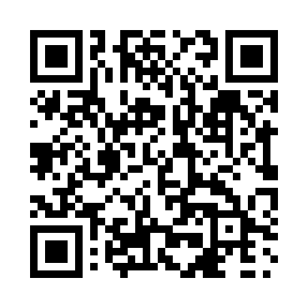
Prayer times for Bluff Creek, Manitoba, Canada
Wed 1 May 2024 - Fri 31 May 2024
High Latitude Method: Angle Based Rule
Prayer Calculation Method: Islamic Society of North America
Asar Calculation Method: Hanafi

Date | Day | Fajr | Sunrise | Dhuhr | Asr | Maghrib | Isha
1 | Wed | 4:14 | 6:08 | 1:32 | 6:39 | 8:58 | 10:52
2 | Thu | 4:12 | 6:06 | 1:32 | 6:40 | 8:59 | 10:54
3 | Fri | 4:09 | 6:04 | 1:32 | 6:41 | 9:01 | 10:57
4 | Sat | 4:06 | 6:03 | 1:32 | 6:42 | 9:02 | 11:00
5 | Sun | 4:03 | 6:01 | 1:32 | 6:43 | 9:04 | 11:02
6 | Mon | 4:01 | 5:59 | 1:32 | 6:44 | 9:05 | 11:05
7 | Tue | 3:58 | 5:58 | 1:32 | 6:45 | 9:07 | 11:07
8 | Wed | 3:55 | 5:56 | 1:32 | 6:46 | 9:08 | 11:10
9 | Thu | 3:52 | 5:54 | 1:32 | 6:47 | 9:10 | 11:13
10 | Fri | 3:50 | 5:53 | 1:32 | 6:48 | 9:12 | 11:15
11 | Sat | 3:47 | 5:51 | 1:32 | 6:48 | 9:13 | 11:18
12 | Sun | 3:44 | 5:50 | 1:32 | 6:49 | 9:15 | 11:21
13 | Mon | 3:41 | 5:48 | 1:32 | 6:50 | 9:16 | 11:24
14 | Tue | 3:39 | 5:47 | 1:32 | 6:51 | 9:17 | 11:25
15 | Wed | 3:39 | 5:45 | 1:32 | 6:52 | 9:19 | 11:25
16 | Thu | 3:38 | 5:44 | 1:32 | 6:53 | 9:20 | 11:26
17 | Fri | 3:37 | 5:42 | 1:32 | 6:54 | 9:22 | 11:27
18 | Sat | 3:37 | 5:41 | 1:32 | 6:55 | 9:23 | 11:28
19 | Sun | 3:36 | 5:40 | 1:32 | 6:55 | 9:25 | 11:28
20 | Mon | 3:35 | 5:39 | 1:32 | 6:56 | 9:26 | 11:29
21 | Tue | 3:35 | 5:37 | 1:32 | 6:57 | 9:27 | 11:30
22 | Wed | 3:34 | 5:36 | 1:32 | 6:58 | 9:29 | 11:30
23 | Thu | 3:34 | 5:35 | 1:32 | 6:58 | 9:30 | 11:31
24 | Fri | 3:33 | 5:34 | 1:32 | 6:59 | 9:31 | 11:32
25 | Sat | 3:33 | 5:33 | 1:32 | 7:00 | 9:32 | 11:33
26 | Sun | 3:32 | 5:32 | 1:32 | 7:01 | 9:34 | 11:33
27 | Mon | 3:32 | 5:31 | 1:33 | 7:01 | 9:35 | 11:34
28 | Tue | 3:31 | 5:30 | 1:33 | 7:02 | 9:36 | 11:34
29 | Wed | 3:31 | 5:29 | 1:33 | 7:03 | 9:37 | 11:35
30 | Thu | 3:31 | 5:28 | 1:33 | 7:03 | 9:38 | 11:36
31 | Fri | 3:30 | 5:27 | 1:33 | 7:04 | 9:39 | 11:36
Prayer times provided by https://www.salahtimes.com

