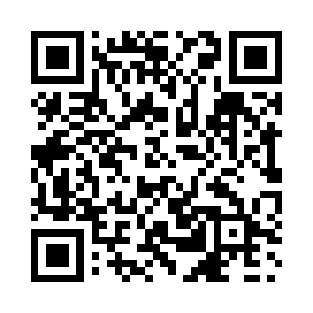
Prayer times for Anurikallak, Quebec, Canada
Wed 1 May 2024 - Fri 31 May 2024
High Latitude Method: Angle Based Rule
Prayer Calculation Method: Islamic Society of North America
Asar Calculation Method: Hanafi

Date | Day | Fajr | Sunrise | Dhuhr | Asr | Maghrib | Isha
1 | Wed | 2:32 | 4:36 | 12:28 | 5:44 | 8:22 | 10:26
2 | Thu | 2:31 | 4:33 | 12:28 | 5:45 | 8:25 | 10:27
3 | Fri | 2:30 | 4:31 | 12:28 | 5:47 | 8:27 | 10:28
4 | Sat | 2:28 | 4:28 | 12:28 | 5:48 | 8:29 | 10:29
5 | Sun | 2:27 | 4:26 | 12:28 | 5:49 | 8:31 | 10:30
6 | Mon | 2:26 | 4:23 | 12:28 | 5:51 | 8:34 | 10:31
7 | Tue | 2:25 | 4:21 | 12:28 | 5:52 | 8:36 | 10:32
8 | Wed | 2:24 | 4:19 | 12:28 | 5:53 | 8:38 | 10:33
9 | Thu | 2:22 | 4:16 | 12:28 | 5:55 | 8:40 | 10:34
10 | Fri | 2:21 | 4:14 | 12:28 | 5:56 | 8:42 | 10:35
11 | Sat | 2:20 | 4:12 | 12:28 | 5:57 | 8:45 | 10:36
12 | Sun | 2:19 | 4:10 | 12:28 | 5:58 | 8:47 | 10:38
13 | Mon | 2:18 | 4:07 | 12:28 | 5:59 | 8:49 | 10:39
14 | Tue | 2:17 | 4:05 | 12:28 | 6:01 | 8:51 | 10:40
15 | Wed | 2:16 | 4:03 | 12:28 | 6:02 | 8:53 | 10:41
16 | Thu | 2:15 | 4:01 | 12:28 | 6:03 | 8:55 | 10:42
17 | Fri | 2:14 | 3:59 | 12:28 | 6:04 | 8:57 | 10:43
18 | Sat | 2:13 | 3:57 | 12:28 | 6:05 | 8:59 | 10:44
19 | Sun | 2:12 | 3:55 | 12:28 | 6:06 | 9:01 | 10:45
20 | Mon | 2:11 | 3:53 | 12:28 | 6:07 | 9:03 | 10:46
21 | Tue | 2:10 | 3:51 | 12:28 | 6:08 | 9:05 | 10:47
22 | Wed | 2:09 | 3:50 | 12:28 | 6:10 | 9:07 | 10:48
23 | Thu | 2:08 | 3:48 | 12:28 | 6:11 | 9:09 | 10:49
24 | Fri | 2:07 | 3:46 | 12:28 | 6:12 | 9:11 | 10:50
25 | Sat | 2:07 | 3:45 | 12:28 | 6:13 | 9:13 | 10:51
26 | Sun | 2:06 | 3:43 | 12:28 | 6:13 | 9:15 | 10:52
27 | Mon | 2:05 | 3:41 | 12:29 | 6:14 | 9:17 | 10:53
28 | Tue | 2:04 | 3:40 | 12:29 | 6:15 | 9:18 | 10:54
29 | Wed | 2:04 | 3:38 | 12:29 | 6:16 | 9:20 | 10:55
30 | Thu | 2:03 | 3:37 | 12:29 | 6:17 | 9:22 | 10:55
31 | Fri | 2:03 | 3:36 | 12:29 | 6:18 | 9:23 | 10:56
Prayer times provided by https://www.salahtimes.com

