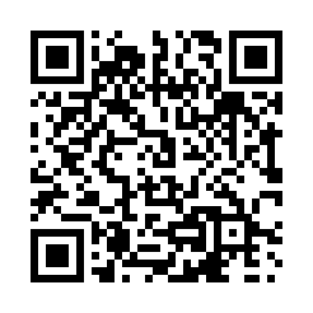

**Prayer times for Qukkialuk, Quebec, Canada**

**Sun 1 Sep 2024 - Mon 30 Sep 2024**

**High Latitude Method: Angle Based Rule**

**Prayer Calculation Method: Islamic Society of North America**

**Asar Calculation Method: Hanafi**

|  |  |  |  |  |  |  |  |
| --- | --- | --- | --- | --- | --- | --- | --- |
| **Date** | **Day** | **Fajr** | **Sunrise** | **Dhuhr** | **Asr** | **Maghrib** | **Isha** |
| 1 | Sun | 3:28 | 5:54 | 1:03 | 5:41 | 8:11 | 10:36 |
| 2 | Mon | 3:29 | 5:56 | 1:03 | 5:39 | 8:07 | 10:35 |
| 3 | Tue | 3:30 | 5:59 | 1:02 | 5:36 | 8:04 | 10:33 |
| 4 | Wed | 3:34 | 6:01 | 1:02 | 5:34 | 8:01 | 10:28 |
| 5 | Thu | 3:38 | 6:04 | 1:02 | 5:31 | 7:58 | 10:22 |
| 6 | Fri | 3:42 | 6:07 | 1:01 | 5:29 | 7:54 | 10:18 |
| 7 | Sat | 3:47 | 6:09 | 1:01 | 5:26 | 7:51 | 10:13 |
| 8 | Sun | 3:51 | 6:12 | 1:01 | 5:24 | 7:48 | 10:08 |
| 9 | Mon | 3:55 | 6:15 | 1:00 | 5:21 | 7:44 | 10:03 |
| 10 | Tue | 3:59 | 6:17 | 1:00 | 5:18 | 7:41 | 9:59 |
| 11 | Wed | 4:02 | 6:20 | 12:59 | 5:16 | 7:38 | 9:54 |
| 12 | Thu | 4:06 | 6:22 | 12:59 | 5:13 | 7:34 | 9:50 |
| 13 | Fri | 4:10 | 6:25 | 12:59 | 5:11 | 7:31 | 9:46 |
| 14 | Sat | 4:13 | 6:28 | 12:58 | 5:08 | 7:28 | 9:41 |
| 15 | Sun | 4:17 | 6:30 | 12:58 | 5:05 | 7:24 | 9:37 |
| 16 | Mon | 4:21 | 6:33 | 12:58 | 5:03 | 7:21 | 9:33 |
| 17 | Tue | 4:24 | 6:35 | 12:57 | 5:00 | 7:18 | 9:29 |
| 18 | Wed | 4:27 | 6:38 | 12:57 | 4:57 | 7:15 | 9:25 |
| 19 | Thu | 4:31 | 6:40 | 12:57 | 4:54 | 7:11 | 9:21 |
| 20 | Fri | 4:34 | 6:43 | 12:56 | 4:52 | 7:08 | 9:17 |
| 21 | Sat | 4:37 | 6:46 | 12:56 | 4:49 | 7:05 | 9:13 |
| 22 | Sun | 4:40 | 6:48 | 12:56 | 4:46 | 7:01 | 9:09 |
| 23 | Mon | 4:44 | 6:51 | 12:55 | 4:43 | 6:58 | 9:05 |
| 24 | Tue | 4:47 | 6:53 | 12:55 | 4:41 | 6:55 | 9:01 |
| 25 | Wed | 4:50 | 6:56 | 12:54 | 4:38 | 6:51 | 8:57 |
| 26 | Thu | 4:53 | 6:59 | 12:54 | 4:35 | 6:48 | 8:54 |
| 27 | Fri | 4:56 | 7:01 | 12:54 | 4:32 | 6:45 | 8:50 |
| 28 | Sat | 4:59 | 7:04 | 12:53 | 4:29 | 6:42 | 8:46 |
| 29 | Sun | 5:02 | 7:07 | 12:53 | 4:27 | 6:38 | 8:43 |
| 30 | Mon | 5:05 | 7:09 | 12:53 | 4:24 | 6:35 | 8:39 |

**Prayer times provided by https://www.salahtimes.com**