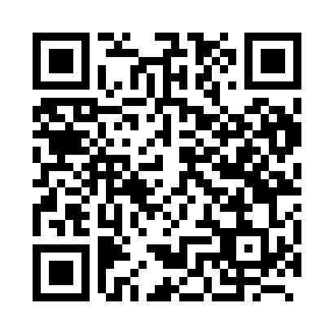
Prayer times for Ellicht, Belgium
Mon 1 Apr 2024 - Tue 30 Apr 2024
High Latitude Method: Angle Based Rule
Prayer Calculation Method: Muslim World League
Asar Calculation Method: Shafi

Date | Day | Fajr | Sunrise | Dhuhr | Asr | Maghrib | Isha
1 | Mon | 5:16 | 7:13 | 1:41 | 5:15 | 8:11 | 10:00
2 | Tue | 5:13 | 7:11 | 1:41 | 5:16 | 8:13 | 10:03
3 | Wed | 5:11 | 7:08 | 1:41 | 5:17 | 8:14 | 10:05
4 | Thu | 5:08 | 7:06 | 1:41 | 5:17 | 8:16 | 10:07
5 | Fri | 5:05 | 7:04 | 1:40 | 5:18 | 8:17 | 10:09
6 | Sat | 5:02 | 7:02 | 1:40 | 5:19 | 8:19 | 10:11
7 | Sun | 4:59 | 7:00 | 1:40 | 5:20 | 8:21 | 10:13
8 | Mon | 4:57 | 6:57 | 1:39 | 5:21 | 8:22 | 10:16
9 | Tue | 4:54 | 6:55 | 1:39 | 5:21 | 8:24 | 10:18
10 | Wed | 4:51 | 6:53 | 1:39 | 5:22 | 8:26 | 10:20
11 | Thu | 4:48 | 6:51 | 1:39 | 5:23 | 8:27 | 10:22
12 | Fri | 4:45 | 6:49 | 1:38 | 5:24 | 8:29 | 10:25
13 | Sat | 4:42 | 6:47 | 1:38 | 5:25 | 8:30 | 10:27
14 | Sun | 4:39 | 6:45 | 1:38 | 5:25 | 8:32 | 10:29
15 | Mon | 4:36 | 6:42 | 1:38 | 5:26 | 8:34 | 10:32
16 | Tue | 4:33 | 6:40 | 1:37 | 5:27 | 8:35 | 10:34
17 | Wed | 4:30 | 6:38 | 1:37 | 5:27 | 8:37 | 10:37
18 | Thu | 4:27 | 6:36 | 1:37 | 5:28 | 8:39 | 10:39
19 | Fri | 4:24 | 6:34 | 1:37 | 5:29 | 8:40 | 10:42
20 | Sat | 4:21 | 6:32 | 1:36 | 5:30 | 8:42 | 10:44
21 | Sun | 4:18 | 6:30 | 1:36 | 5:30 | 8:43 | 10:47
22 | Mon | 4:15 | 6:28 | 1:36 | 5:31 | 8:45 | 10:49
23 | Tue | 4:12 | 6:26 | 1:36 | 5:32 | 8:47 | 10:52
24 | Wed | 4:09 | 6:24 | 1:36 | 5:32 | 8:48 | 10:55
25 | Thu | 4:05 | 6:22 | 1:36 | 5:33 | 8:50 | 10:57
26 | Fri | 4:02 | 6:20 | 1:35 | 5:34 | 8:51 | 11:00
27 | Sat | 3:59 | 6:18 | 1:35 | 5:34 | 8:53 | 11:03
28 | Sun | 3:56 | 6:16 | 1:35 | 5:35 | 8:55 | 11:06
29 | Mon | 3:52 | 6:14 | 1:35 | 5:36 | 8:56 | 11:08
30 | Tue | 3:49 | 6:13 | 1:35 | 5:36 | 8:58 | 11:11
Prayer times provided by https://www.salahtimes.com

