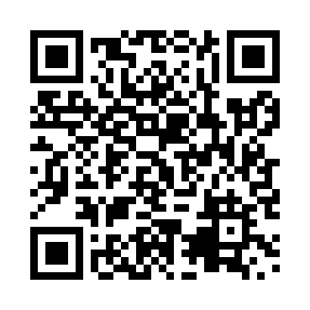

**Prayer times for Sijjaaluit, Quebec, Canada**

**Sun 1 Sep 2024 - Mon 30 Sep 2024**

**High Latitude Method: Angle Based Rule**

**Prayer Calculation Method: Islamic Society of North America**

**Asar Calculation Method: Hanafi**

|  |  |  |  |  |  |  |  |
| --- | --- | --- | --- | --- | --- | --- | --- |
| **Date** | **Day** | **Fajr** | **Sunrise** | **Dhuhr** | **Asr** | **Maghrib** | **Isha** |
| 1 | Sun | 3:20 | 5:36 | 12:39 | 5:18 | 7:41 | 9:56 |
| 2 | Mon | 3:24 | 5:38 | 12:39 | 5:16 | 7:38 | 9:52 |
| 3 | Tue | 3:27 | 5:41 | 12:39 | 5:13 | 7:35 | 9:48 |
| 4 | Wed | 3:31 | 5:43 | 12:38 | 5:11 | 7:32 | 9:43 |
| 5 | Thu | 3:35 | 5:45 | 12:38 | 5:09 | 7:29 | 9:39 |
| 6 | Fri | 3:38 | 5:48 | 12:38 | 5:06 | 7:26 | 9:35 |
| 7 | Sat | 3:41 | 5:50 | 12:37 | 5:04 | 7:23 | 9:31 |
| 8 | Sun | 3:45 | 5:52 | 12:37 | 5:02 | 7:20 | 9:27 |
| 9 | Mon | 3:48 | 5:55 | 12:36 | 4:59 | 7:17 | 9:23 |
| 10 | Tue | 3:51 | 5:57 | 12:36 | 4:57 | 7:14 | 9:19 |
| 11 | Wed | 3:55 | 5:59 | 12:36 | 4:54 | 7:11 | 9:15 |
| 12 | Thu | 3:58 | 6:02 | 12:35 | 4:52 | 7:08 | 9:11 |
| 13 | Fri | 4:01 | 6:04 | 12:35 | 4:49 | 7:05 | 9:07 |
| 14 | Sat | 4:04 | 6:06 | 12:35 | 4:47 | 7:02 | 9:04 |
| 15 | Sun | 4:07 | 6:09 | 12:34 | 4:45 | 6:59 | 9:00 |
| 16 | Mon | 4:10 | 6:11 | 12:34 | 4:42 | 6:56 | 8:56 |
| 17 | Tue | 4:13 | 6:13 | 12:34 | 4:40 | 6:52 | 8:52 |
| 18 | Wed | 4:16 | 6:16 | 12:33 | 4:37 | 6:49 | 8:49 |
| 19 | Thu | 4:19 | 6:18 | 12:33 | 4:35 | 6:46 | 8:45 |
| 20 | Fri | 4:22 | 6:20 | 12:33 | 4:32 | 6:43 | 8:42 |
| 21 | Sat | 4:25 | 6:23 | 12:32 | 4:29 | 6:40 | 8:38 |
| 22 | Sun | 4:27 | 6:25 | 12:32 | 4:27 | 6:37 | 8:35 |
| 23 | Mon | 4:30 | 6:27 | 12:32 | 4:24 | 6:34 | 8:31 |
| 24 | Tue | 4:33 | 6:30 | 12:31 | 4:22 | 6:31 | 8:28 |
| 25 | Wed | 4:36 | 6:32 | 12:31 | 4:19 | 6:28 | 8:24 |
| 26 | Thu | 4:38 | 6:34 | 12:30 | 4:17 | 6:25 | 8:21 |
| 27 | Fri | 4:41 | 6:37 | 12:30 | 4:14 | 6:22 | 8:18 |
| 28 | Sat | 4:44 | 6:39 | 12:30 | 4:11 | 6:19 | 8:14 |
| 29 | Sun | 4:46 | 6:41 | 12:29 | 4:09 | 6:16 | 8:11 |
| 30 | Mon | 4:49 | 6:44 | 12:29 | 4:06 | 6:13 | 8:08 |

**Prayer times provided by https://www.salahtimes.com**