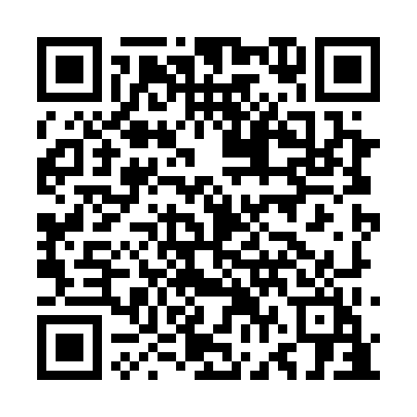
Prayer times for MacDonalds Point, New Brunswick, Canada
Mon 1 Jul 2024 - Wed 31 Jul 2024
High Latitude Method: Angle Based Rule
Prayer Calculation Method: Islamic Society of North America
Asar Calculation Method: Hanafi

Date | Day | Fajr | Sunrise | Dhuhr | Asr | Maghrib | Isha
1 | Mon | 3:40 | 5:39 | 1:28 | 6:52 | 9:17 | 11:16
2 | Tue | 3:41 | 5:39 | 1:28 | 6:52 | 9:17 | 11:15
3 | Wed | 3:42 | 5:40 | 1:29 | 6:52 | 9:17 | 11:15
4 | Thu | 3:43 | 5:41 | 1:29 | 6:51 | 9:16 | 11:14
5 | Fri | 3:44 | 5:41 | 1:29 | 6:51 | 9:16 | 11:13
6 | Sat | 3:45 | 5:42 | 1:29 | 6:51 | 9:16 | 11:12
7 | Sun | 3:46 | 5:43 | 1:29 | 6:51 | 9:15 | 11:11
8 | Mon | 3:48 | 5:44 | 1:29 | 6:51 | 9:15 | 11:10
9 | Tue | 3:49 | 5:45 | 1:30 | 6:51 | 9:14 | 11:09
10 | Wed | 3:50 | 5:45 | 1:30 | 6:50 | 9:14 | 11:08
11 | Thu | 3:52 | 5:46 | 1:30 | 6:50 | 9:13 | 11:07
12 | Fri | 3:53 | 5:47 | 1:30 | 6:50 | 9:12 | 11:06
13 | Sat | 3:55 | 5:48 | 1:30 | 6:50 | 9:12 | 11:05
14 | Sun | 3:56 | 5:49 | 1:30 | 6:49 | 9:11 | 11:03
15 | Mon | 3:58 | 5:50 | 1:30 | 6:49 | 9:10 | 11:02
16 | Tue | 3:59 | 5:51 | 1:30 | 6:48 | 9:09 | 11:01
17 | Wed | 4:01 | 5:52 | 1:30 | 6:48 | 9:09 | 10:59
18 | Thu | 4:02 | 5:53 | 1:31 | 6:48 | 9:08 | 10:58
19 | Fri | 4:04 | 5:54 | 1:31 | 6:47 | 9:07 | 10:56
20 | Sat | 4:06 | 5:55 | 1:31 | 6:47 | 9:06 | 10:55
21 | Sun | 4:07 | 5:56 | 1:31 | 6:46 | 9:05 | 10:53
22 | Mon | 4:09 | 5:57 | 1:31 | 6:46 | 9:04 | 10:51
23 | Tue | 4:11 | 5:58 | 1:31 | 6:45 | 9:03 | 10:50
24 | Wed | 4:12 | 5:59 | 1:31 | 6:44 | 9:02 | 10:48
25 | Thu | 4:14 | 6:00 | 1:31 | 6:44 | 9:01 | 10:46
26 | Fri | 4:16 | 6:01 | 1:31 | 6:43 | 9:00 | 10:45
27 | Sat | 4:18 | 6:02 | 1:31 | 6:42 | 8:58 | 10:43
28 | Sun | 4:19 | 6:04 | 1:31 | 6:42 | 8:57 | 10:41
29 | Mon | 4:21 | 6:05 | 1:31 | 6:41 | 8:56 | 10:39
30 | Tue | 4:23 | 6:06 | 1:31 | 6:40 | 8:55 | 10:37
31 | Wed | 4:25 | 6:07 | 1:31 | 6:39 | 8:54 | 10:35
Prayer times provided by https://www.salahtimes.com

